**SpatGRIS**

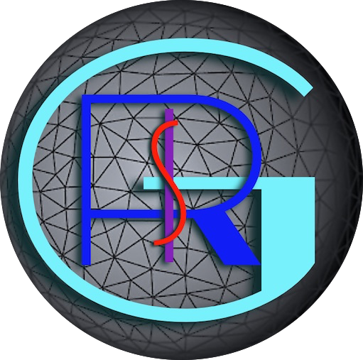

**Tools for 2D and 3D sound spatialization**

Developed by the

Groupe de Recherche en Immersion Spatiale

**GRIS**

<http://gris.musique.umontreal.ca/>

|  |  |
| --- | --- |
| **Director:** | Robert NORMANDEAU |
| **Programmer:** | Gaël LANE LÉPINE |
| **Assistants:** | Nicola GIANNINI |

**Manual**

*SpatGRIS* 3.3.7

*SpeakerView* 0.0.7

*ControlGRIS2* 1.4.5

*BlackHole* 0.6.0

**April 2025**



Faculté de musique

 

**Table of Contents**

1. General presentation 6

1.1. SpatGRIS is a spatialization tool 6

1.1.1. Spatialization 6

1.1.2. Localization 6

1.2. SpatGRIS is a recorder and a player 6

1.3. SpatGRIS makes speaker setups 6

1.3.1. DOME speaker setups 6

1.3.2 CUBE speaker setups 6

1.4. The speakers can be part of the spatialization and the localization 6

1.5. The three components of SpatGRIS 7

1.6. What’s new and improved in ControlGRIS/SpatGRIS? 7

1.7. Groupe de Recherche en Immersion Spatiale (GRIS) 8

2. INTRODUCTION 8

2.1. Architecture 8

2.2. SpatGRIS 9

2.2.1. History 9

2.2.2. System requirements 9

2.2.3. Installation notes 9

2.2.4. Access to the microphone 10

2.2.5. BlackHole volume at 0 dB 10

2.2.6. New Users of BlackHole and macOS 14 Sonoma 10

2.3. ControlGRIS 10

2.3.1. History 10

2.3.2. System requirements 10

2.3.3. Installation notes 11

2.3.4. AU, VST, AAX 11

2.4. Quick Start Guide 12

3. Connections 14

3.1. Connect the DAW to SpatGRIS 14

3.1.1. Open SpatGRIS 14

3.1.2. Adjust the output level 14

3.1.3. Assign the DAW to BlackHole 14

3.1.4. Multiclient 14

3.2. Connect ControlGRIS to SpatGRIS 15

3.2.1. Numbering audio and OSC 15

3.2.2. Sources Colour 16

4. ControlGRIS 17

4.1. Introduction 17

4.2. Graphical interface 17

4.3. Configuration panel 18

4.3.1. Settings 18

MODE 18

OSC Port 18

IP Address 18

Number of Sources 18

First Source ID 18

4.3.2. Sources 18

4.3.3. Controllers 19

4.4. Spatialization views 19

4.4.1 View in DOME mode 19

4.4.2. Spans in DOME mode 20

4.4.3. View in CUBE mode 20

4.4.4. Spans in CUBE mode 21

4.4.5. CUBE Elevation in Normal or Extended Top mode 21

4.4.6. CUBE Elevation in Extended Top and Bottom mode 22

4.5. How to use ControlGRIS 22

4.5.1. Load the plugin on a track 22

4.5.2. Save presets and recording automation 22

4.5.3. Recall presets 23

4.6. Trajectories 23

4.6.1. Sources Link 24

Azimuth-Elevation (DOME) and Azimuth-Distance (CUBE) Links 24

Elevation Links (CUBE mode only) 24

4.6.2. Trajectory Type 24

Azimuth-Elevation (DOME) and Azimuth-Distance (CUBE) Trajectory Type 25

Elevation (CUBE only) Trajectory Type 25

Other settings 25

Realtime 25

Drawing 26

Shift-Click in Drawing mode 26

Activate 27

Trajectory recording in the DAW 27

4.6.3. A special case: the pendulum 27

4.6.4. Presets and automated trajectories 27

5. SpatGRIS 29

5.1. Introduction 29

5.2. SpeakerView 30

5.2.1. Visibility and keyboard shortcuts 30

5.2.2. Two distinct applications 30

5.3. Change the setup not the spatialization 31

5.4. Settings 32

5.5. Controls 32

5.6. The DOME and the CUBE 32

5.6.1. DOME 33

5.6.2. CUBE 33

5.7. The HYBRID mode: DOME and CUBE in the same project 34

5.7.1. What is saved in HYBRID mode? 34

5.72. What Mode is loaded according to the opening order of Speaker Setup and Project? 34

5.7.3. Attenuation settings in CUBE or HYBRID mode 35

5.7.4. Convert from DOME to CUBE and vice versa 36

5.7.5. Spatialization in 2D and 3D 36

5.8. Speaker Setup 37

5.8.1. Speaker Setup Edition 38

5.8.2. Speakers’ order and image representation 38

5.8.3. Minimal requirements 39

5.8.4. Direct outputs 40

Independent direct outputs 40

Spatialized direct outputs 40

5.8.5. Show Speaker Numbers 41

5.9. Sources and Speakers 42

5.9.1. Mute and Solo 43

5.9.2. Peak indicators and Reset 43

5.10. STEREO reduction 43

5.10.1. STEREO 43

5.10.2. BINAURAL 44

5.11. Recording 44

6. PLAYER 46

6.1. To make a recording for the PLAYER 46

6.2. To open and to play a project with the PLAYER 46

6.2.1. Open the listening speaker setup 46

6.2.2. Open the PLAYER window and load the files 47

6.2.3. To play the piece 48

6.2.4. DOME in CUBE or CUBE in DOME 48

6.2.5. Regarding the direct outs in the PLAYER 49

6.3. To save a PLAYER project 50

7. Menus 51

7.1. File menu 51

7.2. View menu 51

7.3. Naming and Saving 52

7.4. Representations 53

7.4.1. 3D Representation 53

7.4.2. 2D Representation 54

7.5. Performance and CPU burst 54

7.6. Help Menu 54

8. Addendum 55

8.1. Sources Link descriptions 55

8.1.1. Azimuth-Elevation and Azimuth-Distance 55

8.1.2. Elevation (CUBE mode only) 56

8.2. Trajectory descriptions 57

8.2.1. Azimuth-Elevation and Azimuth-Distance 57

8.2.2. Elevation (CUBE mode only) 58

8.3. OSC messages in SpatGRIS 58

8.4. OSC messages in ControlGRIS 60

8.5. Open Stage Control and Lemur 60

8.6. Uninstall 60

8.6.1. SpatGRIS 60

8.6.2. ControlGRIS 60

9. Known issues and warnings 61

9.1. Known issues 61

9.1.1. SpatGRIS, Mac version only. 61

9.1.2. ControlGRIS 61

9.1.3. SpatGris, the plugin and SpatGRIS, the software 61

9.2. Reaper 61

9.2.1. Mono tracks 61

9.2.2. Device Preferences with Jack 62

9.3. Logic Pro 62

9.3.1. Only one Surround output 62

9.3.2. Activate buttons 62

9.4. Digital Performer 11 and Automated presets 62

9.5. Using SpatGRIS with live inputs 62

10. Tips and Tricks 63

10.1. Acousmatic spatialisation 63

10.1.1. Mixing console 63

10.1.2. Digital Audio Workstation 63

10.1.3. Acousmatic setup 63

10.1.4. Scenario 64

10.2. Using the PLAYER without you being present 66

10.3. HYBRYD mode to vary the trajectories 66

Index 68

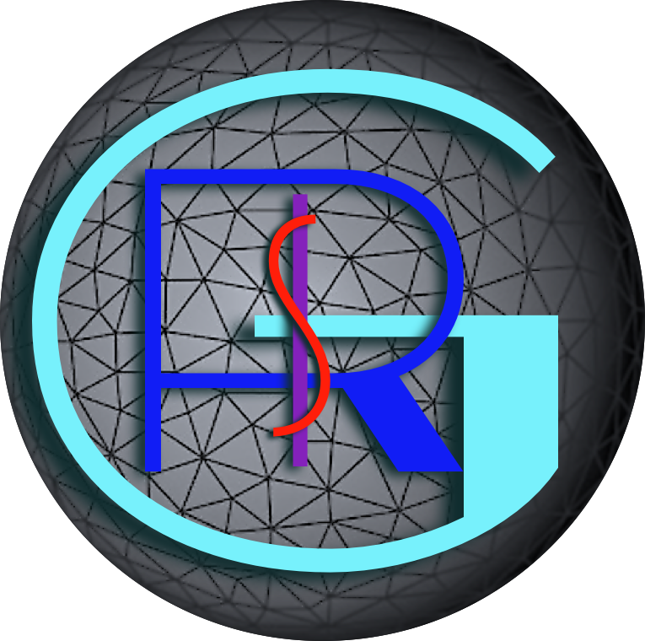

# 1. General presentation

## 1.1. SpatGRIS is a spatialization tool

*SpatGRIS* does spatialization and localization. The spatialization gives the listener the impression of being surrounded by the sound. It’s an immersive experience. The localization is a way to place a sound at a very precise place in the space. The two concepts can be used at the same time in *SpatGRIS*.

### 1.1.1. Spatialization

Using its two algorithms DOME or CUBE, *SpatGRIS* maps the sources — which come from any audio software — to a speaker setup. The position of the sources is provided by OSC messages. The spatialization is done through a speaker system in a physical space.

### 1.1.2. Localization

With the Direct Outputs options (independent or spatialized), *SpatGRIS* makes it possible to access directly to the speakers, for example to manage subwoofers, to place a sound on a particular speaker or to use a channel-based approach to spatialization.

## 1.2. SpatGRIS is a recorder and a player

*SpatGRIS* allows recording the speaker outputs in spatialized modes (DOME or CUBE) or two-channel modes (STEREO or BINAURAL) under two standards - WAV, AIFF - and two formats - Mono Files or Interleaved. With the PLAYER tool, *SpatGRIS* can play any multichannel works recorded with it.

## 1.3. SpatGRIS makes speaker setups

The speaker setup can adopt the form of a DOME or the free form of a virtual CUBE.

### 1.3.1. DOME speaker setups

In the DOME, the distance between every speaker and the centre of the DOME is fixed. Sound sources can be spatialized on the surface of the DOME.

### 1.3.2 CUBE speaker setups

In the CUBE, speakers can be freely arranged in space. There is no fixed distance between the speakers and the centre of the setup. Unlike DOME setups, sound sources can enter, pass through, and exit the setup. Sound sources that are outside the setup can be treated with attenuation parameters (volume and filter).

## 1.4. The speakers can be part of the spatialization and the localization

Each loudspeaker has a unique number — whether in spatialized mode or as a direct output — and can be used for these two functions: spatialization and localization, thanks to the new direct output functions. A speaker can be part of the spatialization and at the same time be a direct output. This is a major conceptual difference compared to previous version.

## 1.5. The three components of SpatGRIS

There are three components in *SpatGRIS* that are saved independently: Project, Speaker Setup and Settings.

• Save Project. A project is coupled with a work and contains a certain number of sources.

• Save Speaker Setup. A speaker setup is coupled with a physical installation placed in a space.

• Save Settings. User settings are linked to a workstation (computer and audio interface), including the stereo outputs used for stereo reduction.

## 1.6. What’s new and improved in ControlGRIS/SpatGRIS?

• *SpatGRIS* is independent from any audio virtual device, either *Jack, Enzian* or *BlackHole*. It’s the user’s choice.

• Direct Outs now have two functions: Independent, for speakers that are not part of the spatialization, e.g. subwoofers; Spatialized, through which the sound can be sent directly to any speaker that is part of the speaker setup.

• Compatibility with the newest version of MacOS, from 10.15 (Catalina) to 14.7 (Sonoma) and new machines (M1-M2-M3).

• ProTools compatibility with the addition of the *ControlGRIS* AAX format*.*

• STEREO and BINAURAL can be assigned to any outputs of the sound card.

• Several speaker setups and projects templates are now integrated in the software.

• *ControlGRIS* and *SpatGRIS* are available for Windows.

**What’s new:**

***SpatGRIS***

• Version 3.3.7

- A general MUTE button has been added.

• Recent additions and patches

- SpeakerView: Keep speaker numbers up-to-date

- The 3D window representing speakers and sources is now independent of *SpatGRIS*. The graphical representation is now done in *SpeakerView*, with a much-improved graphical interface.

- *SpatGRIS* and *BlackHole* are now 256 channels each.

- CUBE Mode: Attenuation settings have a Bypass toggle button.

- CUBE Mode: negative Z attenuation begins at the floor.

- Stereo Reduction: Attenuation settings is functional in Stereo reduction when in Cube or Hybrid mode.

- Attenuation settings: They are saved with the projects.

- Introduction of the PLAYER, a tool which allows *SpatGRIS* to be used as a standalone software to play any piece recorded by it to any speaker setup.

- CUBE mode uses a new algorithm: MBAP (Matrix Based Amplitude Panning).

- Speaker Setup Edition in CUBE and HYBRID modes: added a Global Sound Diffusion parameter.

- Introduces theHYBRID mode that combines the DOME and the CUBE algorithms.

- Show numbers has been split into Show Source Numbers and Show Speaker Numbers.

***ControlGRIS***

• Version 1.4.5

- Fixes different issues with the Windows installer

- Provides the possibility to place signals outside the CUBE on the Z axis.

**Improvements and Fixes**

• The Speaker Setup Edition has been greatly optimized.

• Better compatibility in the parameters between *ControlGRIS* and *SpatGRIS.*

• A lot of very practical enhancements and changes in the terminology!

## 1.7. Groupe de Recherche en Immersion Spatiale (GRIS)

Director: Robert Normandeau.

Main programmer: Gaël Lane Lépine.

Consultant: Devin Roth, creator of BlackHole.

Assistant.es: Nicola Giannini.

Former programmers: Samuel Béland, Olivier Bélanger, Vincent Berthiaume.

Former assistants: Simone d’Ambrosio, Theo Mathien, Raphaël Néron-Baribeau, Ofer Pelz, Dominic Thibault, Alexis Langevin-Tétrault, Vincent Monastesse, David Ledoux, Yohan Brimicombe, Christophe Lengelé, Mélanie Frisoli, David Piazza, Gabrielle Caux..

Former trainees: Ludovic Laffineur, Antoine Landrieu, Nicolas Masson, Hicheme Ben Gaied.

The GRIS received research grants from Hexagram, SSHRC and FRQSC since 2008 and up to 2025.

Thanks to Yohan Brimicombe for the creation of the web site: <http://gris.musique.umontreal.ca>

# 2. INTRODUCTION

These instructions assume that you are familiar with the following tools:

• The DAW you use, which must support AU, VST, VST3 or AAX plugins.

• Your audio interface.

## 2.1. Architecture

The *SpatGRIS* system is made of three elements:

• The *ControlGRIS* plugin where the trajectories are designed and recorded in a DAW (or any OSC device).

• The *SpatGRIS* itself that spatializes the sound, according to the setup of the speakers done in the Speaker Setup Edition window.

• The virtual audio device *BlackHole[1]* which connects the DAW to *SpatGRIS*.

The whole architecture, including these elements, looks like this (audio and OSC are working in parallel):



NOTE: In each track of the DAW, it’s mandatory that the audio output channel numbers match the OSC source numbers (set by the First Source ID parameter) in the corresponding ControlGRIS instance to have the sound to be spatialized in *SpatGRIS*. Failure to do so will lead to silence or frozen spatialization.

## 2.2. SpatGRIS

*SpatGRIS* is a standalone application that allows the spatialization of sounds on different speaker configurations, in 2D or 3D. It could be used with the virtual audio interface *BlackHole* that may provide up to 256 inputs and outputs. The trajectories are sent from the *ControlGRIS* plugin, or from any other OSC software[2] to *SpatGRIS*. The audio spatialization itself is performed by *SpatGRIS* and sent to the audio interface.

### 2.2.1. History

The development of *SpatGRIS* began in 2020. It is a rewritten version of *ServerGris* (2018) and *SpatGRIS2* (2020). The first official version of *SpatGRIS* is 3.0.0 and was released in August 2021. It was our first *Jack[3]* free spatialization tool!

### 2.2.2. System requirements

The software has been tested on the following OS:

• macOS from 10.15 Catalina™ to 14.7 Sonoma™

• It is native on Apple Silicon M1-M2-M3 machine (version 3.1.8 and up).

• Windows™ 10, 11.

### 2.2.3. Installation notes

• Download the latest version of *SpatGRIS* from SourceForge:

[https://sourceforge.net/projects/SpatGRIS3/](https://sourceforge.net/projects/spatgris3/)

*SpatGRIS* for Mac comprises two installers in the same folder:

SpatGRIS_v3:

• *SpatGRIS* itself.

• *SpeakerView* in three versions: Forward (recommended), Compatibility and Mobile

• *ControlGRIS* as a compressed folder with the different formats of the plugin.

BlackHole:

• The virtual audio device *BlackHole* that provides 64, 128 or 256 audio channels between the DAW and *SpatGRIS.*

Notes for MacOS users

• *SpatGRIS*, along with *SpeakerView* and a folder of utilities, are now installed in a GRIS folder (in the Applications folder). It is possible to rename the GRIS folder (to have multiple installations, for example), but it is not advisable to rename anything inside this folder.

• To facilitate focus management between *SpeakerView* and *SpatGRIS*, we recommend that you allow *SpeakerView* to control your computer when requested. If *SpeakerView* does not request this, go to System Settings > Privacy & Security > Accessibility, and authorize *SpeakerView*.

*SpatGRIS, SpeakerView, ControlGRIS* and *BlackHole* will be updated separately. Please subscribe to our newsletter to be informed about the software updates on our web site.

Two external controllers are available for *ControlGRIS*:

• An Open Stage Control patch for iPad™.

• A Lemur patch[4] for iPad™.

An Addendum manual pertaining to these *iPad* controllers is available on SourceForge.

*SpatGRIS* for Windows has one installer:

• *SpatGRIS* itself.

• *ControlGRIS* as a compressed folder with the different formats of the plugin.

There is no Windows version of *BlackHole*. For Reaper™ users, there is the *ReaRoute* function which works similarly to *BlackHole*, but only for Reaper. It is possible to use *Jack* on Windows[5]. When *BlackHole* is mentioned in the manual, replace it by *ReaRoute* or *Jack* when using Windows.

### 2.2.4. Access to the microphone

NOTE: Very important for Catalina (10.15) users and up.

Make sure that *SpatGRIS* has access to the microphone in the System Preferences, Security & Privacy:

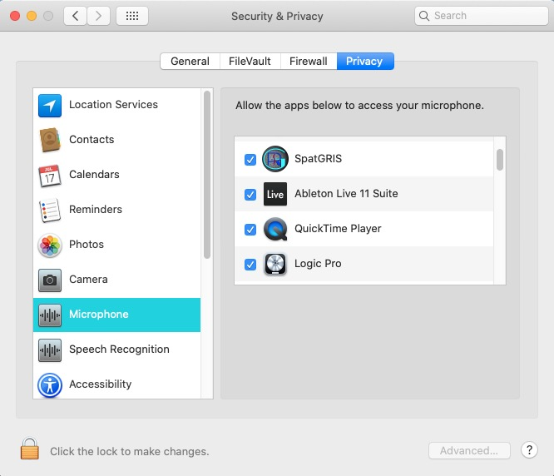

### 2.2.5. BlackHole volume at 0 dB

After installing or reinstalling Blackhole, please make sure that the volume of BlackHole is at 0 dB in the Audio Midi Setup.

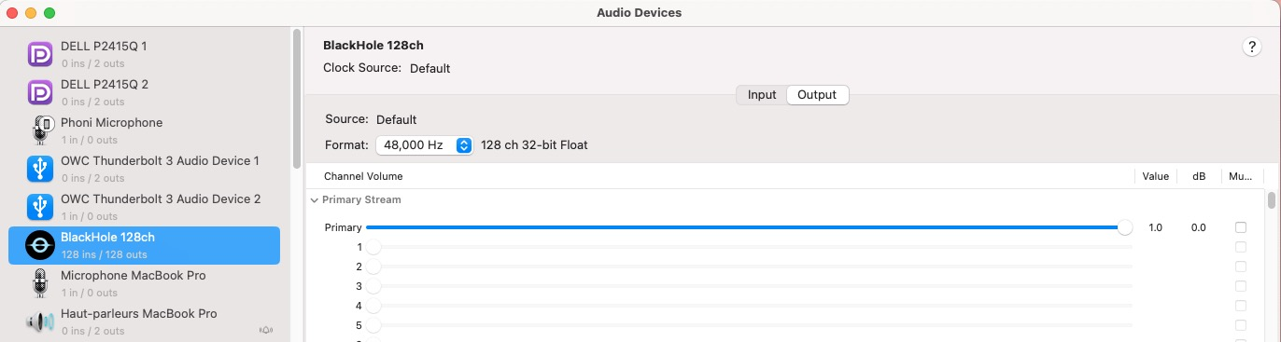

### 2.2.6. New Users of BlackHole and macOS 14 Sonoma

NOTE: New users of BlackHole and macOS 14 Sonoma should use the latest BlackHole installer 0.6.0.

## 2.3. ControlGRIS

*ControlGRIS* is an OSC[6] plugin available in AU, VST, VST3 and AAX formats (Mac) and VST and AAX formats (Windows). This free and open-source plugin sends OSC data to *SpatGRIS* to spatialize multiple sound sources on a variable set of speakers. Different modes of source links and a trajectory system are provided for spatialization of mono, stereo and multichannel sources (up to eight channels).

### 2.3.1. History

The development of *ControlGRIS* began in 2019. It was inspired by three older plugins, *OctoGris* (2010), *ZirkOSC* (2012) and *SpatGris1*(2017). The first version (1.1.0) was released in April 2020.

### 2.3.2. System requirements

The software has been tested on the following OS and DAWs:

• macOS from 10.15 Catalina™ to 14.7 Sonoma™; Digital Performer™ 10 and 11; Ableton Live™ 10 and 11; Logic Pro™ 10; Reaper™ 6; Pro Tools™ 2023.6.

• It is native on Apple Silicon M1-M2-M3 machines (version 1.3.2 and up).

• Windows™ 10, 11; Reaper™ 6.

### 2.3.3. Installation notes

Download the latest version of *ControlGRIS* from SourceForge (the installer is included in the *SpatGRIS* installer):

<https://sourceforge.net/projects/spatgris3/>

Decompress the downloaded file. The different formats will be installed in their proper location. *ControlGRIS* appears under the “UdeM” folder of your host application.

### 2.3.4. AU, VST, AAX

Mac versions were intensively tested but the Windows 10 and 11 versions, not so much!

Comments are welcome.

Here are some particularities:

• Use the AU version in DP and Logic Pro on the Mac.

• Use the VST3 version in Reaper and Live.

• Use the AAX version in ProTools[7].

• Refer to the manual of your preferred DAW to determine which version is better.

## 2.4. Quick Start Guide

*SpatGRIS* receives Open Sound Control (OSC) data from *ControlGRIS*, to spatialize the sounds within a set of speakers. The sound itself is sent from the DAW to *SpatGRIS* via *BlackHole*.

Don't need/want to read the manual? Here are the basic steps to spatialize a stereo track on a 64-output audio interface.

NOTE: Adjust the Buffer size to the same value in both your DAW and SpatGRIS. A value of 256 and up is recommended.

1. Open *SpatGRIS.*

2. Open the Settings (File menu) or click them directly in the Info bar and assign the Audio input device to *BlackHole 128ch* and the Audio output device to your audio interface (you must do that only the first time). Close the window.

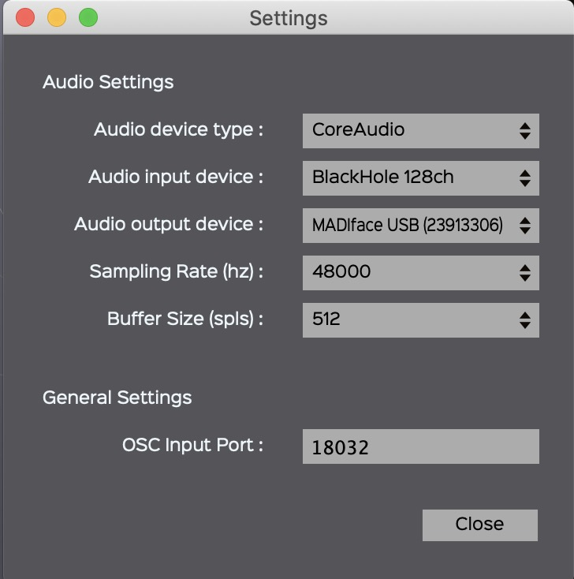

3. Open a DOME Speaker Setup (File menu) or use the default one.

4. Open your DAW.

5. Assign the audio output of your DAW to *BlackHole 128ch.*

6. Create a stereo track and assign the outputs *to BlackHole 128ch 1-2.*

7. Insert a *ControlGRIS* plugin on this track and set it to DOME mode.

8. The number of sources should be already initialized and set at 2 and First Source ID set at 1.

9. Select *Circular Fully Fixed* in *Sources Link* and start the sequencer.

10. Play with Source No. 1 and see the result in *SpatGRIS.*

11. The colour of the sources are the ones selected in the Sources (the red dots in this example).

You are now ready to play and record automation.





NOTE: In each track of the DAW, it’s mandatory that the audio output numbers match the OSC numbers (set by the First Source ID parameter) in the corresponding ControlGRIS to have the sound to be spatialized in SpatGRIS. Not doing that will lead to silence, or to freeze spatialization.

Questions? Details? Read the manual!

This manual is in the Help menu:

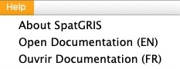

# 3. Connections

## 3.1. Connect the DAW to SpatGRIS

### 3.1.1. Open SpatGRIS

The first time you open *SpatGRIS*, you'll have to:

• Determine the numbers of sources (up to 256). 64 would be enough in most cases, but fewer sources mean less CPU load. Or use one of the projects included in the Templates menu.

• Design a speaker setup or use one in the Templates menu.

After these first two steps, save the Speaker Setup and the Project. At the next start-up of SpatGRIS, the last saved Speaker Setup and Project will be loaded.

### 3.1.2. Adjust the output level

By default, the output level of *SpatGRIS* is set to unity gain: 0.00 dB. It may need to be attenuated or increased, especially if it is the first time you try the system!

### 3.1.3. Assign the DAW to BlackHole

Open your DAW and assign *BlackHole* as the audio output device*.* *BlackHole* should be detected like any other audio interface in Core Audio. It is possible to allocate a certain number of active channels according to the number set in Set Sources (± icon).



### 3.1.4. Multiclient

*SpatGRIS* is a multiclient software, which means that it can connect to multiple audio software at the same time. Keep in mind, though, that its primary usage is to spatialize sounds coming out of a single DAW. The software receives two types of information:

• Audio signals from *BlackHole*

• OSC data from *ControlGRIS*.

Both signals are needed for the sound spatialization. For direct outputs, only the audio signal is needed.

If you use only one DAW, there is no problem, but it’s mandatory that the audio output numbers match the OSC numbers (set by First Source ID parameter) in the corresponding *ControlGRIS* to have the sound to be spatialized in *SpatGRIS*. Not doing that will lead to silence, or to freeze spatialization. Things become a little bit more complicated if you intend to use more than one software at a time.

• *BlackHole* has a limited number of 256 channels in total. If you want to connect a DAW with 24 channels and another one with 8 channels, keep in mind that the second DAW will have to be set to channels No. 25-32 in *BlackHole* andand it will be necessary that ControlGRIS uses the corresponding OSC numbers.

NOTE: Adjust the Buffer size to the same value in both your DAW and SpatGRIS. A value of 256 and up is recommended.

## 3.2. Connect ControlGRIS to SpatGRIS

### 3.2.1. Numbering audio and OSC

The spatialization is handled by *SpatGRIS* which receives OSC data from *ControlGRIS2*. It is mandatory to synchronize *BlackHole* audio output numbers in the DAW with the OSC numbers in *ControlGRIS2*.

In the following example, three stereo tracks (red, blue, and green) are assigned to *BlackHole* channel pairs 1-2, 3-4 and 5-6. The three instances of *ControlGRIS2* use the same OSC numbering: 1-2, 3-4 and 5-6.



To help to keep things clear, it is recommended to use the same colour scheme in the DAW and in *SpatGRIS*.



NOTE: If by mistake, you are using the same OSC numbers in more than one ControlGRIS instance, the sources in SpatGRIS will oscillate between different positions because they will receive two (or more) of the same position from different *ControlGRIS*. It's a good indicator that something is wrong.

### 3.2.2. Sources Colour

The colour of the sources can be set to any value by clicking in the colour square. It opens a window where you can set the parameters of the colour. This is the colour you will see in the 2D or the 3D window. If you use a lot of sources, it is recommended that you design your colour set carefully.

After closing this window, you can set the same colour to the next source on the right by using right-clicking on a colour. You can set this way the same colour to a pair of sources or to many contiguous sources.

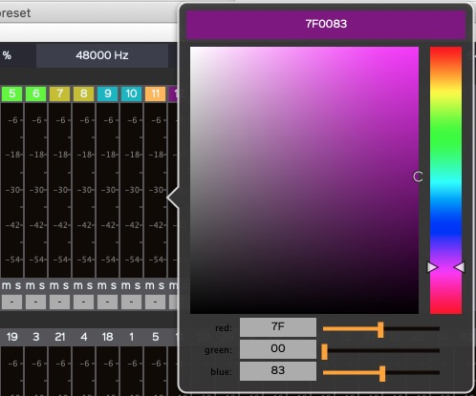

# 4. ControlGRIS

*ControlGRIS* is an OSC plugin that offers two possibilities, according to the mode chosen in *SpatGRIS*:

• DOME.

• CUBE.

These two modes will be explained in detail in the *SpatGRIS* section.

## 4.1. Introduction

*ControlGRIS* is an OSC spatialization plugin. This plugin allows movements of multichannel sound sources on a variable set of speakers. Several sources link modes and a trajectory system are provided to allow the spatialization of mono, stereo, quad, 5.1 or multichannel sources of up to eight channels. *ControlGRIS* doesn't handle audio, only data which is sent to *SpatGRIS*. The audio itself is sent from the DAW directly to *SpatGRIS via BlackHole*.

This document describes the operating instructions and functions specific to *ControlGRIS*. It is assumed that the user has a working knowledge of the host software and can perform basic functions to configure it.

## 4.2. Graphical interface

Thegraphical interface allows the placement of the sound sources. It is slightly different in DOME than in CUBE mode. In DOME, since the Distance is fixed at 1.00, there are only the Azimuth and Elevation parameters to adjust. In CUBE, the three parameters, Azimuth-Distance and Elevation are adjustable on two different windows.



## 4.3. Configuration panel

The configuration panel gives access to different plugin parameters. These settings are grouped under three tabs: Sources, Settings and Controllers.

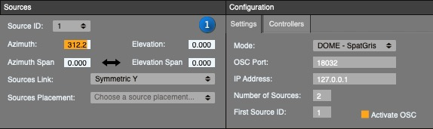

### 4.3.1. Settings

#### MODE

The DOME mode is based on the VBAP algorithm designed by Ville Pulkki. In this mode, the space is represented by a dome where the distance between every point of the surface to the centre of the dome is equal to 1.00.

The CUBE mode is based on an original MBAP[8] algorithm designed by Gaël Lane Lépine. In this mode, the space is represented by a cube within which it is possible to design any kind of speaker setup.

#### OSC Port

This is the OSC port number for communication between *ControlGRIS* and *SpatGRIS*. They should be set to the same one. 18032 is the default value.

#### IP Address

The default value here is 127.0.0.1 which corresponds to the address of the internal device (i.e. your computer). This can be changed to send the OSC to an external computer.

#### Number of Sources

The number of sources per track corresponds to the number of audio channels in the track. The number is limited to eight channels (as it is in most DAWs).

#### First Source ID

This number must be unique and different for each audio channel. You must use the same numbers for audio and for OSC.

If you have only mono tracks, the numbers are successive. If you have stereo tracks, you'll have only odd numbers to put here: 1, 3, 5, etc. because the even numbers are set automatically to the right channel of each stereo track. And if you work with octophonic sound files, the first source ID will be 1, the second octophonic track will start at 9, etc.

### 4.3.2. Sources

Under the Sources tab, it is possible to accurately position sources by using the graphical interface or the text boxes. Using Sources Placement, it is possible to position sources equidistantly, following a clockwise or alternate order. To do so, simply select the desired layout from the drop-down menu.

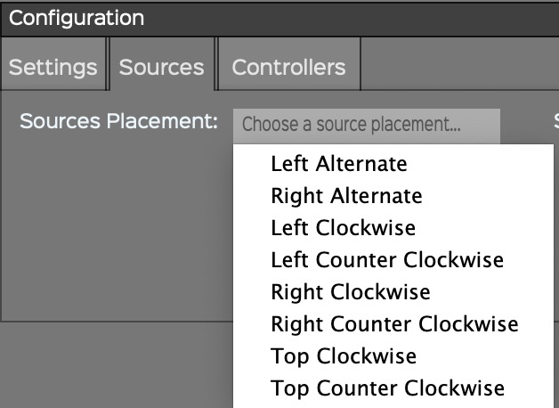

Moreover, it is possible to manually adjust the position of each source by entering its polar (DOME) or Cartesian (CUBE) coordinates. From the Source Number drop-down menu, first select the number of the source to be moved. Then, enter its new coordinates.

In DOME, Elevation and Azimuth correspond to the current polar coordinates of the selected source:

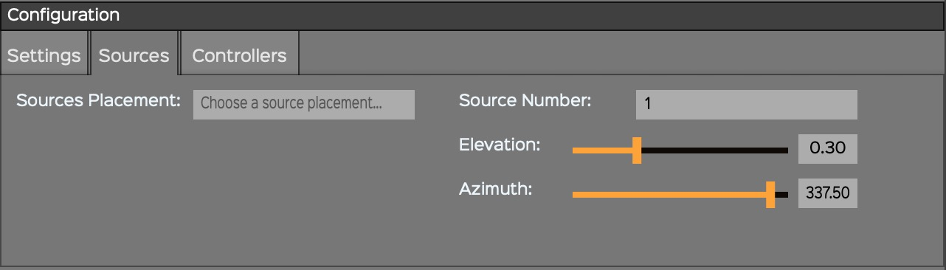

In CUBE, X, Y, and Z correspond to the current Cartesian coordinates of the selected source:

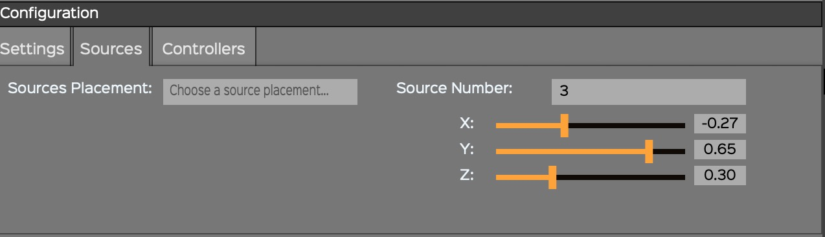

**NOTE: Manual positioning of individual sources only works when the Independent mode is chosen under Sources Link.**

### 4.3.3. Controllers

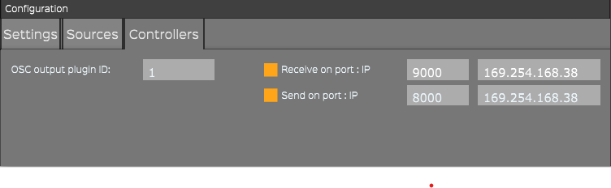

*ControlGRIS* can be manipulated via an external Open Sound Control[9] (OSC) controller. There is an interface made for Open Stage Control and one made for Lemur to manipulate *ControlGRIS* parameters from an iPad[10].

• OSC output plugin ID: to control different instances of *ControlGRIS*, each one should have a different ID.

• Receive and Send should be set accordingly to the proper OSC channels (Default: 9000 and 8000).

• IP port addresses should be set accordingly to your Wi-Fi network, either public or local[11]. Both the computer and the controller should be on the same network. *ControlGRIS* automatically receives the input address from your network.

## 4.4. Spatialization views

*ControlGRIS* works in two different modes for sound spatialization: DOME and CUBE.

### 4.4.1 View in DOME mode

In DOME mode, the graphical interface is limited to Azimuth-Elevation. In this mode, the sound is spatialized on the surface of the dome. Whereas a source placed in the centre is at the top of the dome, a source placed at the periphery is at the bottom of the dome.

The dome is represented here from the top, examples with a stereo source on the left, an octophonic source on the right:

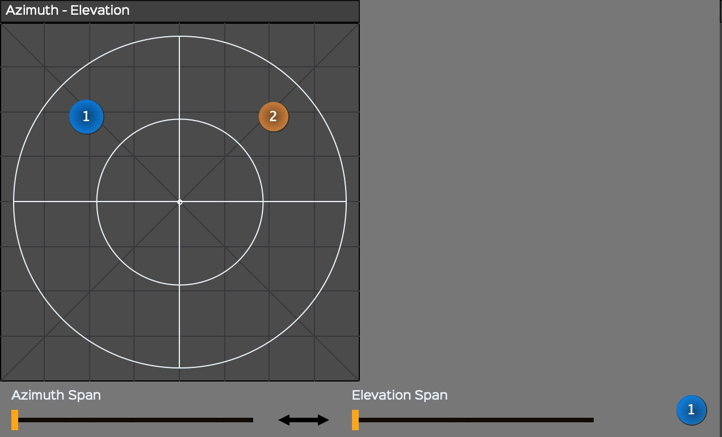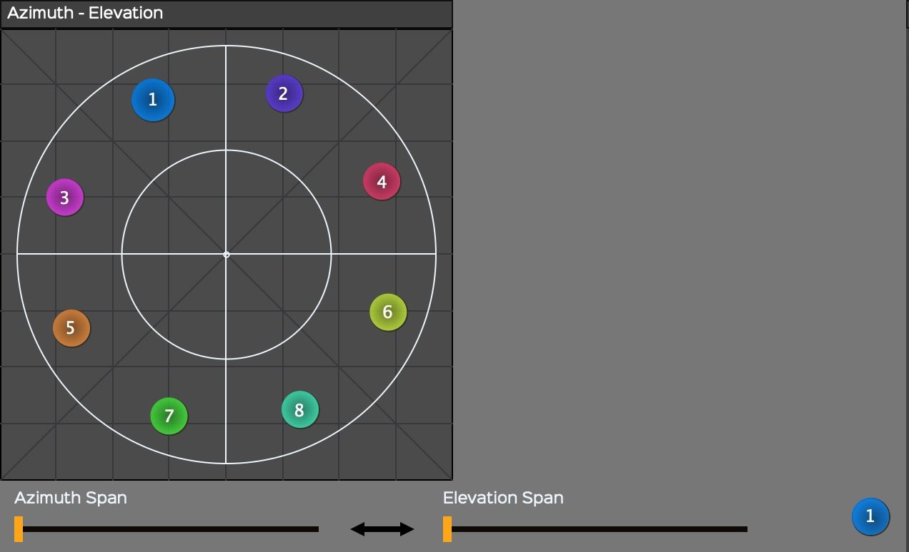

### 4.4.2. Spans in DOME mode

In both modes, Span parameters are available for azimuth and elevation. Span spreads the signal to a larger zone than just the source itself. In DOME mode, the spans look like an arc on each side of the source:

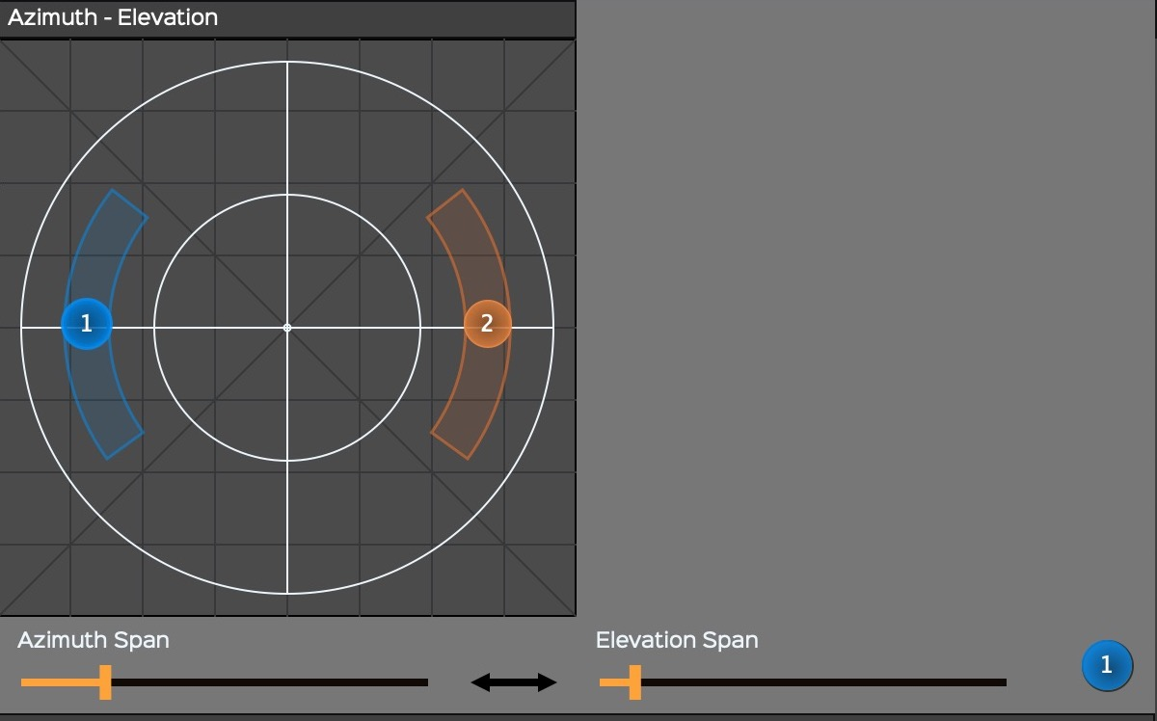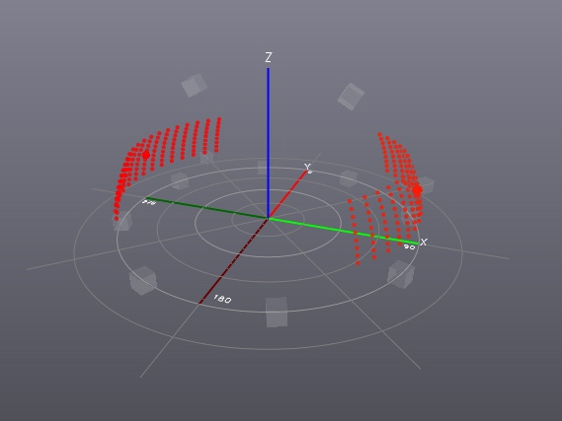

### 4.4.3. View in CUBE mode

In CUBE mode, the graphical interface is divided between two screens: Azimuth-Distance and Elevation. The CUBE mode adds distance and allows moving a sound inside or outside the speaker setup (represented by the internal white square). The CUBE is represented from the top on the left and in profile on the right (the 3D view shows only in *SpatGRIS*). Examples for stereo and octophonic sources:

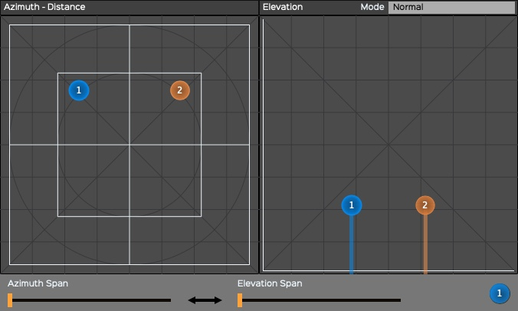 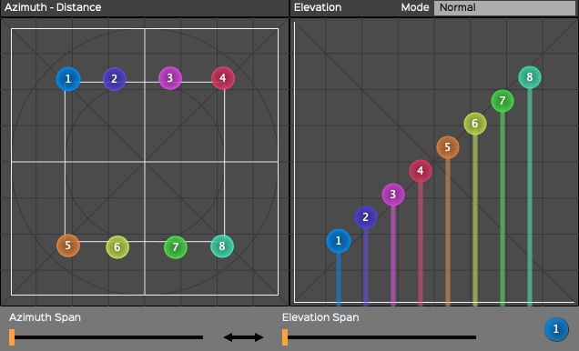

### 4.4.4. Spans in CUBE mode

In CUBE mode, the spans look like a cylinder wrapped around the source:

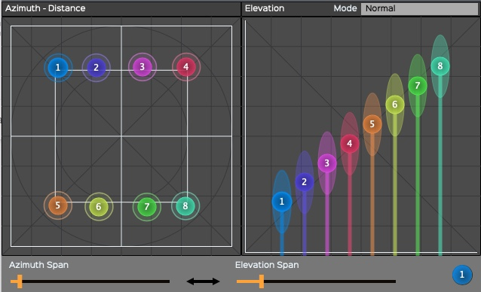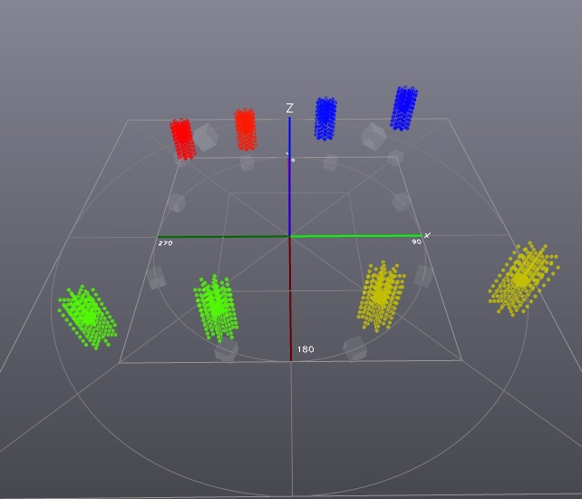

In some CUBE setups, where most speakers are spread across the walls and the ceiling, a source can be lost in the centre of the hall. If you wish to create a flat sound disk that activates only the speakers located at the same height as the source, you can add a bit of Azimuth Span:

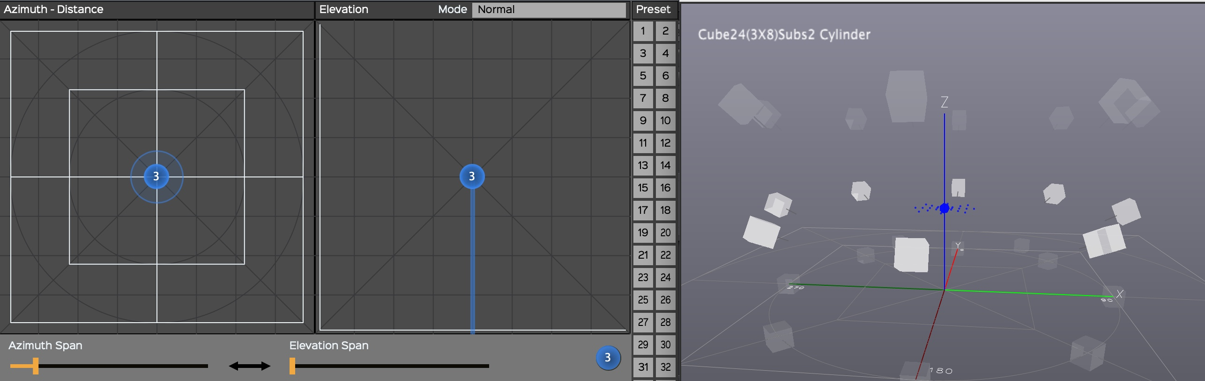

### 4.4.5. CUBE Elevation in Normal or Extended Top mode

Since version 1.4.1, *ControlGRIS* offers the possibility to put a source outside of the CUBE in elevation. This was already possible on the *x* and *y* axes, and it is now possible on the *z* axis. When using the Extended Top mode, a white horizontal line appears in the elevation diagram. This line represents the value 1.0 used in the Normal mode. This is the point at with *SpatGRIS* Attenuation Settings start to take effect in elevation. Sources will be filtered either in volume and/or in frequencies as they move further away from the top of the cube:

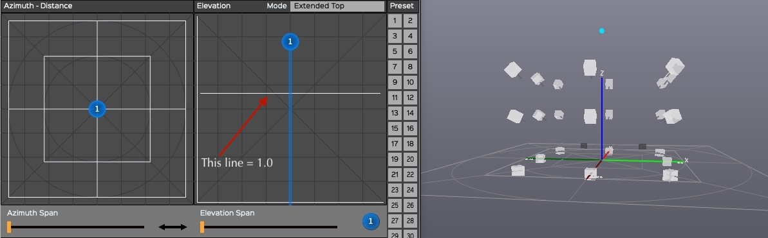

### 4.4.6. CUBE Elevation in Extended Top and Bottom mode

A second line appears in Extended Top and Bottom mode to attenuate the sounds that are sent below the floor (for the lucky few who have access to a full cube!) The top line represents the value 1.0 of the normal mode. The bottom line represents the value 0.0 of the Normal mode:

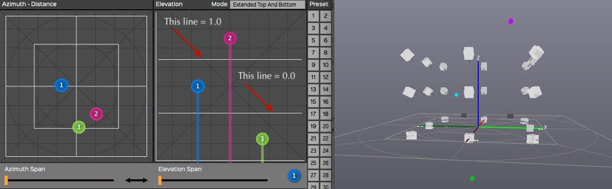

NOTE 1: Older projects can still be used in the Normal mode where the full range from 0.00 to 1.00 is still available.

NOTE 2: It's not yet possible to go below the floor in a complete sphere with ControlGRIS in DOME mode. We are working on that. But it's possible to do so by using any software that sends OSC directly to SpatGRIS.

## 4.5. How to use ControlGRIS

*ControlGRIS* is a plugin that can be inserted on any track that requires spatialization. *ControlGRIS* comprises a trajectory system that can write predefined movements quickly and efficiently.The automation function of the host software assures the recording and playback of the source's movements. It is therefore essential to understand the various automation modes in your preferred host.

### 4.5.1. Load the plugin on a track

*ControlGRIS* is loaded similarly to any other AU or VST plugin. Most often, *ControlGRIS* is loaded at the end of the insert chain of the track.

NOTE: In each track of the DAW, it’s mandatory that the audio output numbers match the OSC numbers (set by the First Source ID parameter) in the corresponding ControlGRIS to have the sound to be spatialized in SpatGRIS. Not doing that will lead to silence, or to freeze spatialization.

### 4.5.2. Save presets and recording automation

It is possible to save some of the *ControlGRIS* plugin parameters within the 50 provided preset slots. The shortcuts are:

• Shift-Click Preset number: Save.

• Click Preset number: Load.

• Opt[12]-Click Preset number: Delete.

These functions appear below the rows 49-50:

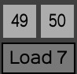

These presets allow you to save and recall the following parameters only:

• Source positions (Azimuth-Distance-Elevation). These can also be automated.

The parameters that are not saved but can be automated:

• Spans.

• Sources Link and Sources Link Alt.

• Presets.

• Bypass.

The parameters that are not saved and not automated, because they are used to automatically generate a trajectory that will be written by the DAW itself:

• Spans link.

• Trajectory Type.

• Dur per cycle.

• Sec(s)/Beat(s).

• Number of cycles dampening.

• Deviation degrees per cycle.

• Back & Forth.

• Activate.

Configuration tab

• The whole Configuration tab is not saved in the preset (this one is saved with the DAW project). It is not a good idea to change these settings within a track.

NOTE: While it is possible to record the position of all sources in presets, it is only possible to record the automation of the source No. 1 in the sequencer. Source No. 1 is the leader while other sources are followers.

### 4.5.3. Recall presets

As mentioned above, the presets store only the position of the sources. When a preset is loaded, the sources are positioned according to the stored data. Keep in mind though that the sequencer also has a memory of the previous position of the sources, and both can interact strangely. Very often then, it's only when you start the sequencer that the sources take their real positions. To avoid any ambiguity, presets selection can be automated.

## 4.6. Trajectories

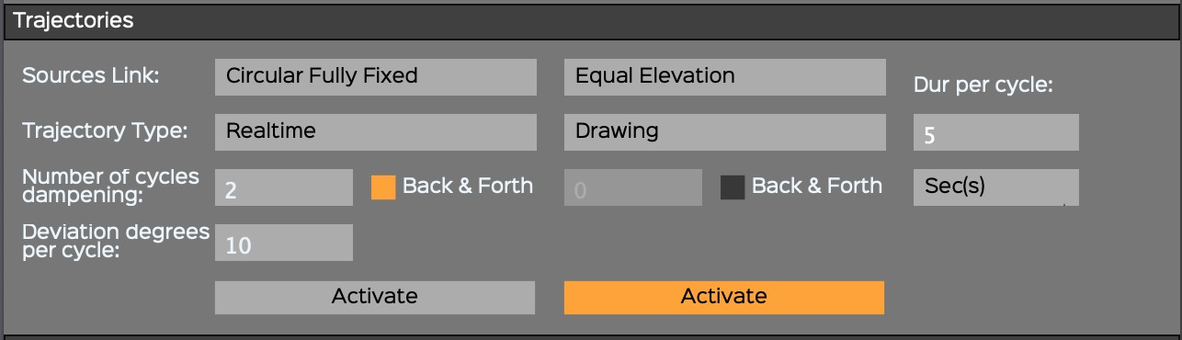

It is possible to automate the movement of sound sources using predefined trajectories. Within the Trajectories control panel, you can set and adjust these movements to the musical context. The concept behind the trajectories is that there is a source leader while the others are followers. Only the source No. 1 can be the leader.

If you try to record the automation of any other source than No. 1, you’ll get this warning:

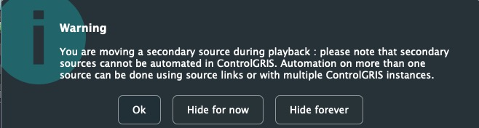

### 4.6.1. Sources Link

Independent mode is only available for initially placing sources independently in a multichannel track. But the position of sources can't be automated independently. Only the automation of the Source No. 1 can be recorded. Therefore, after placing the sources, a different source link should be chosen before recording the automation.

#### Azimuth-Elevation (DOME) and Azimuth-Distance (CUBE) Links

Within the *Trajectories* section, under the *Sources Link* drop-down menu, it is possible to choose different ways of linking sources together. Depending on the number of channels, some links may not be available:

• Mono: Independent only.

• Stereo: all links.

• Multichannel: all but Symmetric X and Y.

• Detailed representations of the Azimuth-Elevation and Azimuth-Distance Links are shown at the Addendum 8.1.1.

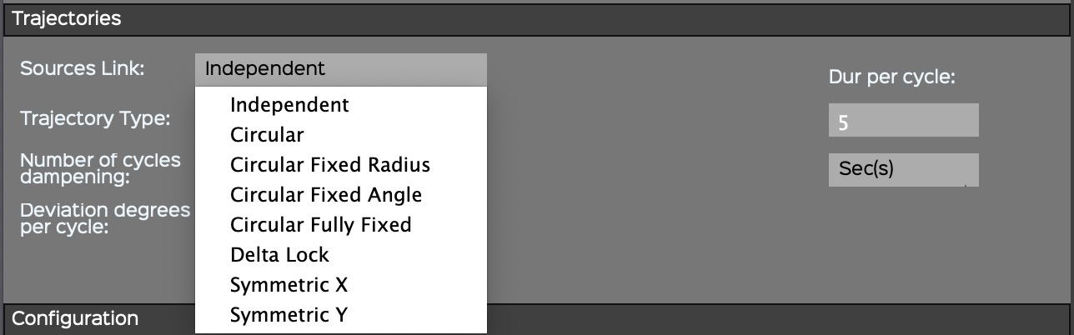

#### Elevation Links (CUBE mode only)

In CUBE mode, the Elevation Links between sources are independent from the Azimuth-Distance parameters.

• Detailed representations of the Elevation Links are shown at the Addendum 8.1.2.

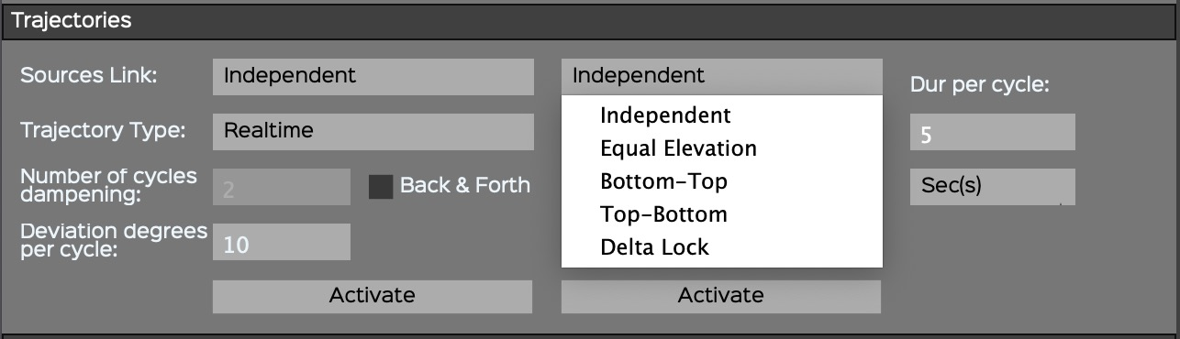

### 4.6.2. Trajectory Type

Automating the movement of a source is quite simple with the different trajectory types provided.

• Detailed representations of the Trajectories are shown at the Addendum 8.2.

#### Azimuth-Elevation (DOME) and Azimuth-Distance (CUBE) Trajectory Type

A drop-down menu allows you to select from different types of trajectories such as *Circle*, *Ellipse*, *Spiral*, *Square* and *Triangle,* either in *Clockwise* or *Counter Clockwise* mode.

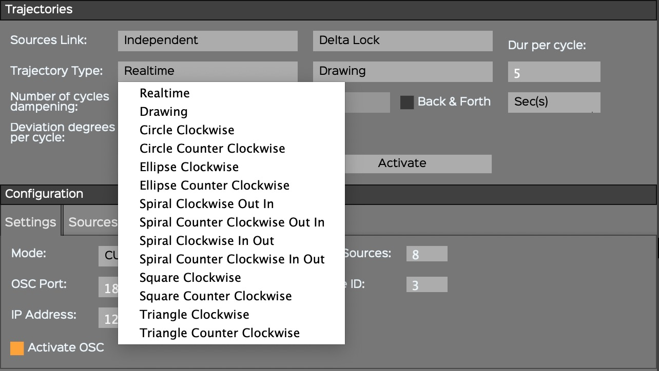

#### Elevation (CUBE only) Trajectory Type

A drop-down menu with different types of trajectories allows you to select from a variety such as *Up Down*, *Down Up.*

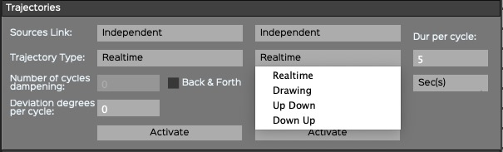

#### Other settings

• The duration of the trajectory in *second(s)* or *beat(s)* (linked to the MIDI tempo of the host sequencer).

• The Number of cycles dampening: the total duration = Dur per cycle x Number of cycles x 1,5. Dampening works only with Back & Forth.

• The Back & Forth option.

• The Deviation degrees per cycle.

#### Realtime

This is the usual automation recording: you move a parameter (or several parameters) and it is recorded in the DAW.

#### Drawing

The Drawing mode allows you to draw a trajectory directly into the plugin itself. This trajectory can then be modified by editing the duration, dampening and deviation. When the desired settings are found, they can be recorded in the DAW itself.



The Drawing mode is a freehand mode. When you select it, a light grey cross will appear with which you draw a trajectory. The timing of the trajectory and the design are temporarily stored within the plugin. In Azimuth-Elevation (DOME) or Azimuth-Distance (CUBE), it's the position that is recorded. In Elevation (CUBE only) it's the position over time. Both windows share a cycle that can be modified with the regular parameters. To see the trajectory in action, you can turn on the Activate buttons and play the sequence. When the sequencer stops, the Activate buttons return to off. Changes can be made and then it's possible to switch on Activate again. Once satisfied with the results, you can then record the trajectory in the DAW.

#### Shift-Click in Drawing mode

If Shift is pressed in the Drawing mode, it's possible to design straight lines or irregular geometrical figures in the Azimuth-Elevation (DOME) or the Azimuth-Distance (CUBE) window. Every time you click, a new angle is created. Don't forget to click one last time once you’re finished!

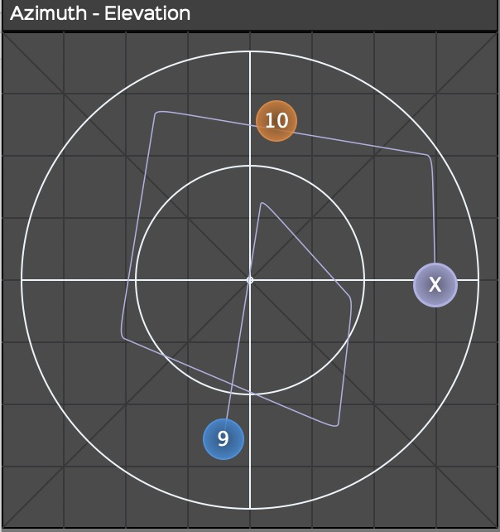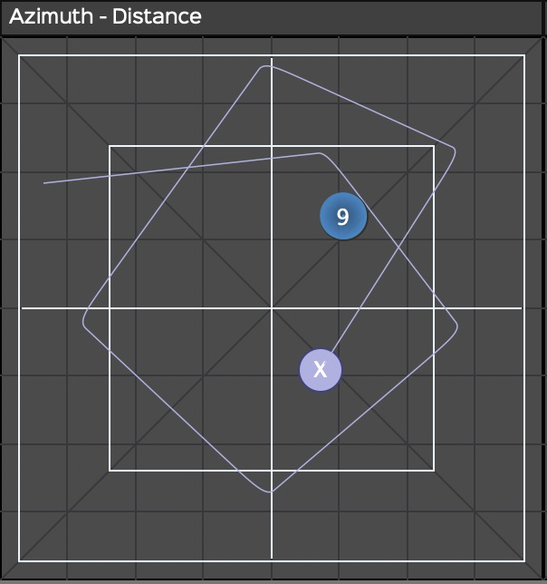

**NOTE: Be careful with the freehand trajectory because it’s temporary. If you click anywhere in the window after drawing a trajectory, or close the plugin or the session, it will automatically be erased. Only one gesture can be temporarily recorded at a time. The X cross can be hidden behind one of the sources. Just move one of those to find it back.**

#### Activate

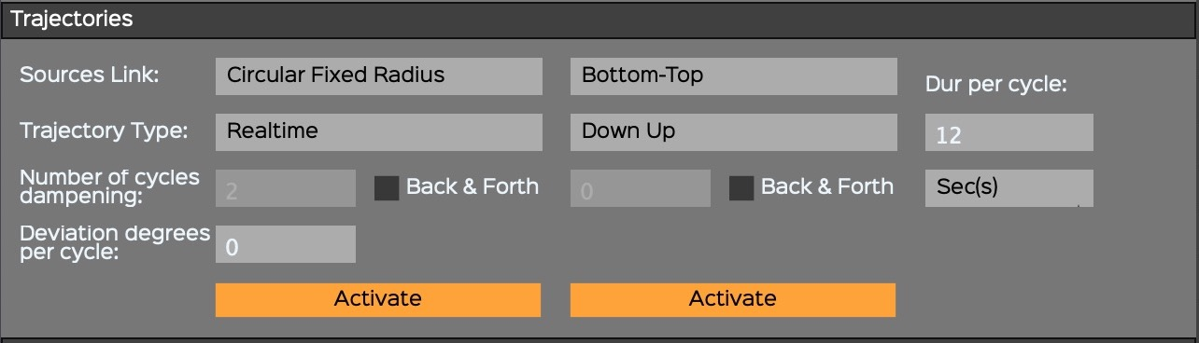

Pressing the Activate button makes *ControlGRIS* wait for the start of the sequencer. When the sequence is initiated, the plugin will start the trajectory according to the specified settings. The movement produced can be recorded — X, Y and Z-coordinates of the source No. 1 — like any other automation. When the sequencer stops, the *Activate* buttons return to off. It's important to put the play head at the right position before pressing on the activate button and putting the sequence into play.

#### Trajectory recording in the DAW

As explained above, *ControlGRIS* waits for the host sequencer to start before starting a trajectory. The tracks that contain *ControlGRIS* can be set in a write mode (Touch, Latch, or Write — depending on the options within your DAW) to record the sources' movements as automation. This automation is then available for playback and editing.

NOTE: Only the source No. 1 (leader) is recorded, the other sources being followers. It is always preferable to record the automation of trajectories in the DAW after you have found the right settings, because it frees up the CPU used by ControlGRIS.

### 4.6.3. A special case: the pendulum

A specific use of the Shift-Click in Drawing mode can be used to design a pendulum. If a simple line is drawn with Shift-Click, it constitutes the basic element of a pendulum. Then the Dur per cycle, Dampening, Deviation and Back & Forth can be used to make this pendulum very interesting. It can be placed anywhere in the space.

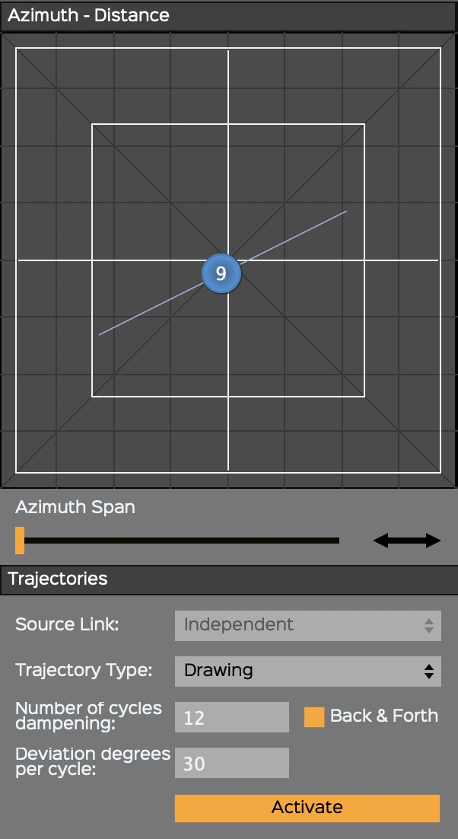

### 4.6.4. Presets and automated trajectories

It's possible to record the presets selection in the sequencer. But to avoid contradictory information between automated trajectories and automated presets (which stores x-y position of the sources), in automation recording, the x and y coordinates, registered in the preset, will be automatically written in the x-y automation curves. The automated presets are designed essentially to offer the possibility to apply sudden changes in the position of the sources.



NOTE: Be careful with that. If you overwrite the already existing X and Y automations, they might become in competition with the information stored in the presets. Then you will certainly get audio glitches.

# 5. SpatGRIS

• *SpatGRIS* does spatialization and localization.

• *SpatGRIS* is a recorder and a player.

• *SpatGRIS* makes speaker setups.

## 5.1. Introduction

There are three components in *SpatGRIS* that are saved independently: Project, Speaker Setup and Settings.

• **Save Project**. A project is coupled with a work that contains a certain number of sources (outputs from the DAW) and the Mode used. This is the component on the top right of *SpatGRIS*.

• **Save Speaker Setup**. A speaker setup is coupled to an installation placed in a space and the algorithm used. This is the section shown in *SpeakerView*.

• **Save Settings**. User settings are linked to a workstation — computer and audio interface — including the stereo outputs used for stereo reduction (even without showing them). Most of the settings are shown in the Info bar. Click the Info bar or Settings in the File menu (Cmd-,).

NOTE: The DOME and the CUBE modes are saved in Speaker Setups and Projects, but the HYBRID mode is only saved in projects. The last opened document — whether it be a Speaker Setup or a Project — determines the Mode.

The *SpatGRIS* window is divided into different zones:

• Sources

• VU Meters.

• Settings and Info.

• Controls.

• Recording.

*SpeakerView* shows the speakers in a 3D view.



## 5.2. SpeakerView

As of *SpatGRIS* version 3.3.3, the 3D representation of loudspeakers is supported by an independent application called *SpeakerView.* This change was necessary in order to meet the requirements of Apple Silicon processors for Mac. Everything is better here: speaker transparency, number legibility and fluidity of movement have all been dramatically improved.

*SpeakerView* is shown here with the new Show Hall function:

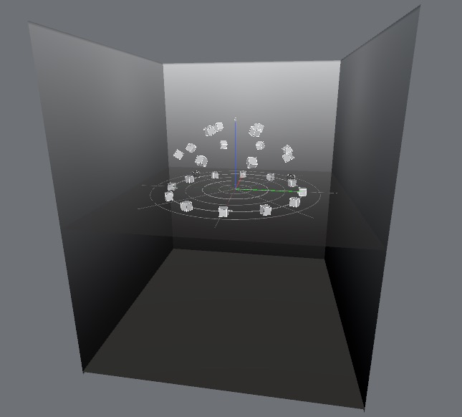

### 5.2.1. Visibility and keyboard shortcuts

*SpeakerView* is displayed independently of *SpatGRIS*. By default, it is displayed at the same time as *SpatGRIS*. However, it can be opened or closed independently (Mac: Opt-V. Windows: Alt-V).

Keyboard shortcuts in the *SpatGRIS* View menu control display options in *SpeakerView*:

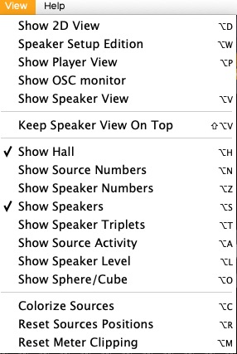

### 5.2.2. Two distinct applications

Although *SpeakerView* resembles the 3D representation that existed in versions *of SpatGRIS* prior to 3.3.0, it is a separate application. It can be moved and sized independently. You can also choose to force it to stay on top of *SpatGRIS* (Keep SpeakerView On Top).

NOTE: SpeakerView is an autonomous application, but there is no need for the user to worry about that, *SpatGRIS* will take care of everything. We even strongly recommend that *SpeakerView* shouldn't be started neither from the Finder nor the Dock. If it's opened this way, this the warning message that will pop up:

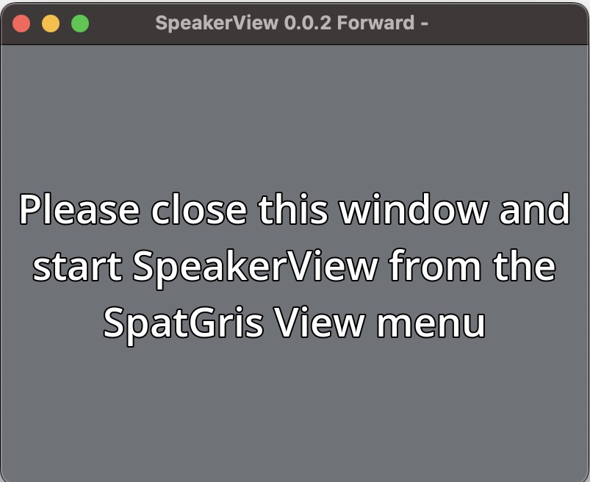

## 5.3. Change the setup not the spatialization

The most interesting feature in *SpatGRIS* is that the *Sources,* which come from the DAW and represent the audio and the spatialization of your work, are independent of the *speakers*. So, if you initially defined a very complex spatialization structure for a specific speaker arrangement, you could play it on any other speaker setup afterwards, especially in DOME mode. You simply have to change the Speaker Setup from one location to the next.

Here's an example of a piece designed for a 16-Speaker Setup (on the left), presented on an entirely different 24-speaker system (right), simply by switching from one system to the other.

As you can see, all the sources remain at the exact same coordinates. They will be played by different speakers but heard at the same location in the concert hall.

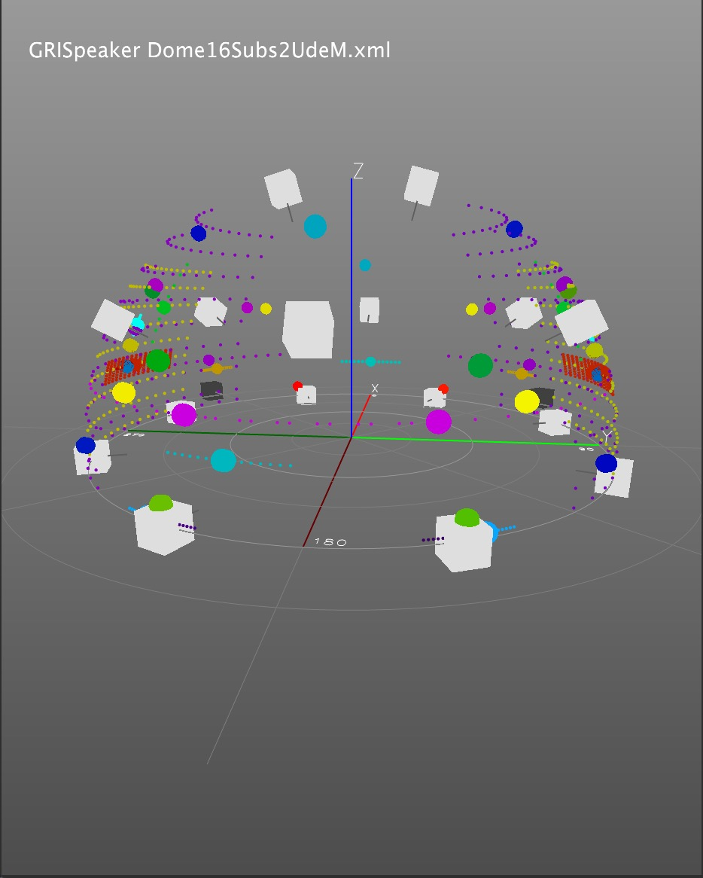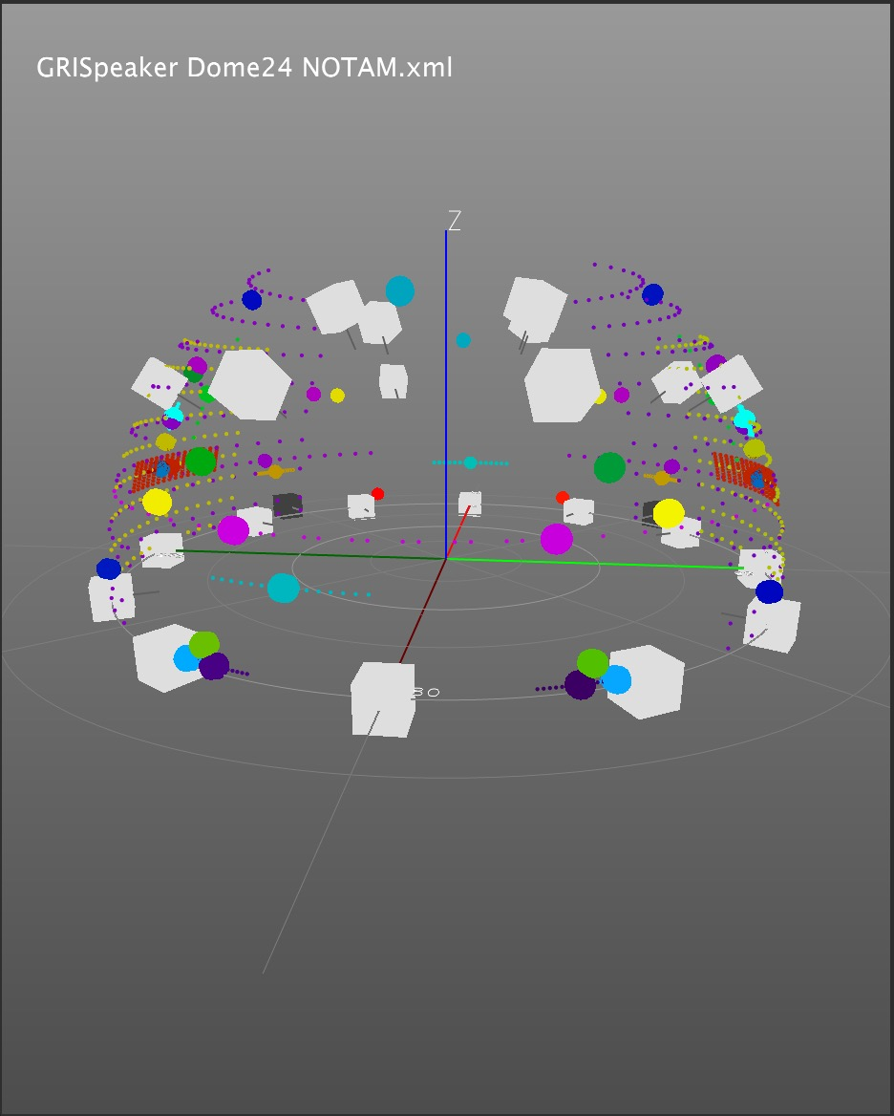

## 5.4. Settings



Audio Settings

• Audio device type: Core Audio (default).

• Audio input device: *BlackHole* (ideally).

• Audio output device: your audio interface.

• Sampling Rate (Hz): from 44100 to 192000, according to your audio interface.

• Buffer Size (spls): from 16 to 2048. Adjust the Buffer size at the same value in your DAW and in *SpatGRIS*.

General Settings:

• OSC Input Port: default is 18032 which is the same as *ControlGRIS*. If you want to use another incoming OSC device, use this port number as the output port of that device, otherwise you must change this number accordingly.

**Close**

Your settings are automatically saved. Under the name of the version of *SpatGRIS,* the document is located here (Mac):

• ~/Library/Application Support/GRIS/SpatGRIS.0.0 (for example).

## 5.5. Controls



## 5.6. The DOME and the CUBE

In DOME mode, it is possible to place the sources on the surface of the dome made by the speaker setup while in CUBE mode it is possible to move and place the sources inside and outside the speaker setup.

### 5.6.1. DOME

The DOME based onVBAP (Vector Base Amplitude Panning), allows the user to spatialize the sound on a dome of speakers according to the relative amplitude of three speakers (as opposed to two in stereo panning). Therefore, the dome is made of triangles of speakers. This way, the sound can travel smoothly on the surface of the dome, with no bumps or holes.

It is possible to see the triangles by choosing Show Speaker Triplets (Opt-T) in the *View* menu. If you have the chance to use a complete sphere, it is possible to show it (Opt-O)!

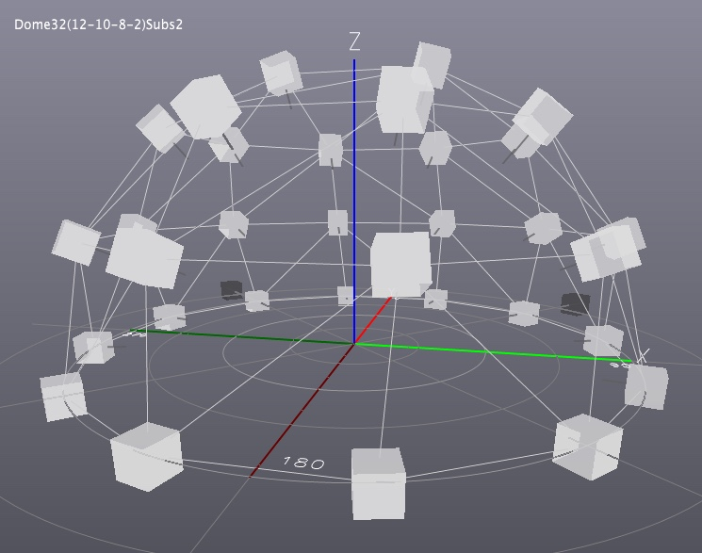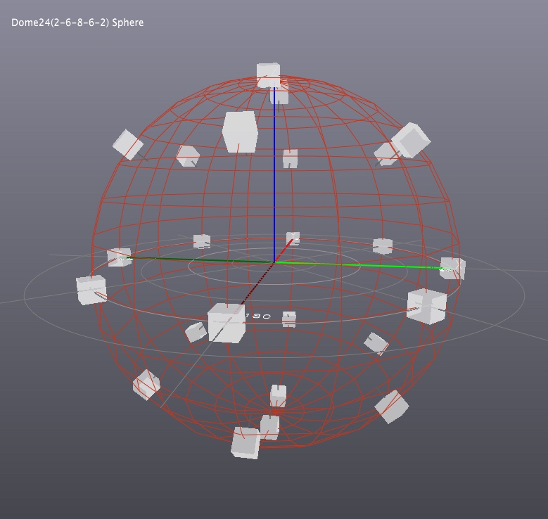

### 5.6.2. CUBE

Since version 3.2.0, the CUBE is based on the MBAP algorithm (Matrix Base Amplitude Panning) and it allows the placement of a source anywhere in a space represented by a cube. But it is not limited to the shape of a cube. Any speaker setup can be placed within a cube (including a dome!) Therefore, any sound installation or concert situation can be simulated here. In CUBE mode, the distance of the source exiting the speaker setup is considered to simulate the natural behaviour of the sound moving away.

As the name suggests, the algorithm is based on a precomputed three-dimensional matrix of multiple points per speaker that determines the amplitude of a source at a specific position.

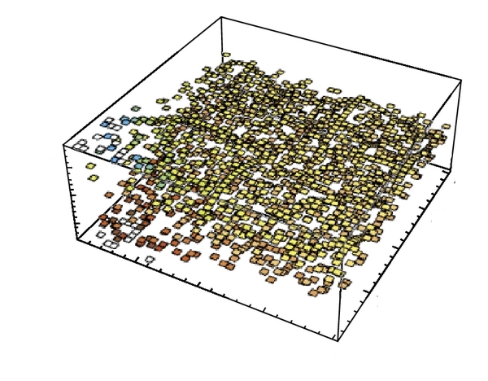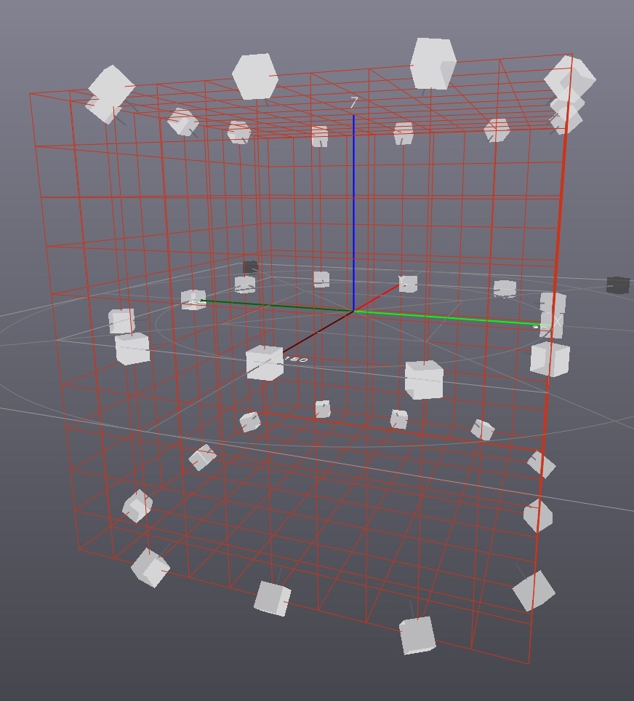

## 5.7. The HYBRID mode: DOME and CUBE in the same project

The HYBRID mode is not really a new algorithm, but a combination of the DOME and the CUBE ones. HYBRID mode can be selected in the Algorithm section:

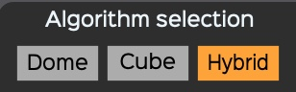

The Sources menu is then changed to offer the possibility of choosing between the dome or the cube behaviour independently for each source:

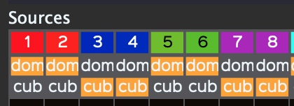

The HYBRID mode uses the DOME algorithm, which means that the speaker setup must be a dome (if not, you will be asked to convert it) within which the sources can be moved according to CUBE behaviours where it's possible to move the sound inside or outside the dome of speakers. In HYBRID mode, the spans keep their usual dome or cube behaviour.

### 5.7.1. What is saved in HYBRID mode?

There are two types of information that are saved with the project in HYBRID mode:

• The HYBRID mode itself is saved exclusively with the project.

• The selection of the DOME or the CUBE algorithm for each source is also saved with the project.

### 5.72. What Mode is loaded according to the opening order of Speaker Setup and Project?

As a rule, it is always the last opened document — Speaker Setup or Project — that determines the algorithm used by *SpatGRIS*.

A Speaker Setup (SS) followed by a Project (P):

1.1. SS Dome + P Dome = Dome.

2.1. SS Cube + P Cube = Cube.

3.1. SS Dome + P Cube = Cube. The SS Dome has been converted to SS Cube. The shape of the SS does not change, since the Cube algorithm accepts all domes (this can be confirmed by opening the Speaker Setup Edition window). Before closing the SS, you'll be asked to save the changes.

4.1. SS Cube + P Dome = Dome. The SS Cube is converted into a Dome after the conversion message is approved.

5.1. SS Dome + P Hybrid = Hybrid.

6.1. SS Cube + P Hybrid = Hybrid. SS Cube is converted to Dome after the conversion message is approved.

In reverse order:

1.2. P Dome + SS Dome = Dome.

2.2. P Cube + SS Cube = Cube.

3.2. P Cube + SS Dome = Dome. The Cube project has been converted to SS Dome.

4.2. P Dome + SS Cube = Cube. The Dome project has been converted to SS Cube.

5.2. P Hybrid + SS Dome = Hybrid. This is the only exception where Hybrid has priority, despite the fact it was loaded first. It's because Hybrid projects works on SS Dome only.

6.2. P Hybrid + SS Cube = Cube. Hybrid disappears from the view since we have just switched to Cube. This is normal. By selecting Hybrid manually afterwards, the SS Cube is converted into a Dome after the conversion message is approved. The saved information of the P Hybrid is then recovered.

### 5.7.3. Attenuation settings in CUBE or HYBRID mode

In CUBE and HYBRID modes, there are an inner circle and an outer circle in the middle of the Speaker Setup. Within the inner circle, attenuation and/or filtering are not applied. Outside the inner circle, attenuation and/or filtering can be applied to simulate the vanishing of a sound at a faraway distance. At the outer circle, attenuation and filtering reach their maximum values. You can indicate these maximum values in the Attenuation settings menus. In HYBRID mode, Attenuation settings work only on CUBE sources.



Actually, the inner circle is a sphere within which the attenuation settings start to be calculated from the «floor», that is to say from the coordinates (0.0, 0.0):

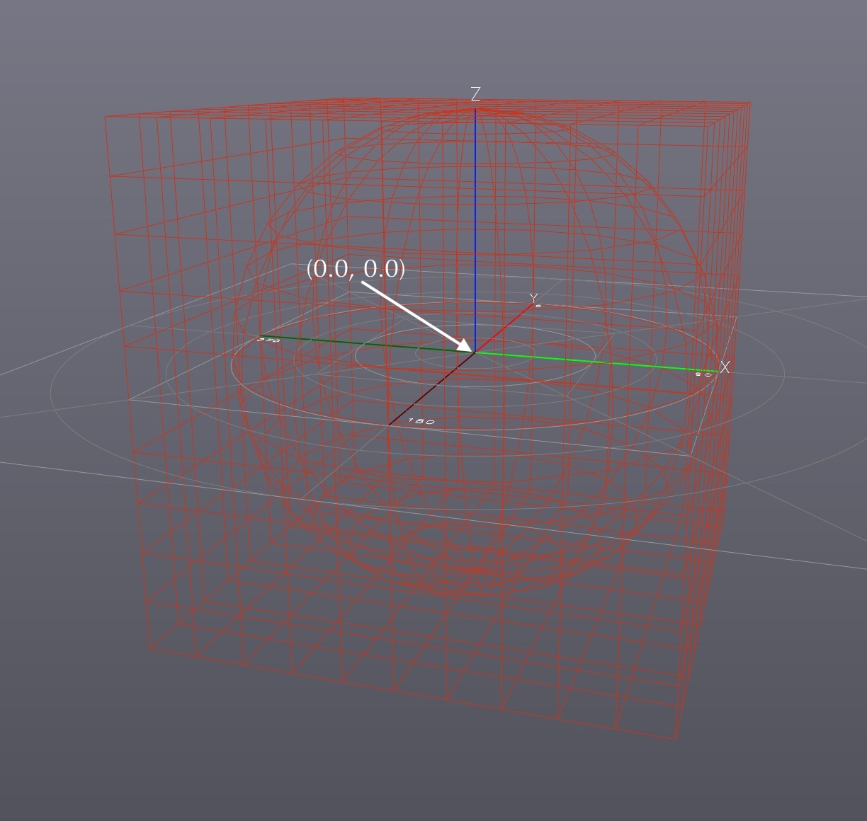

Attenuation settings parameters:

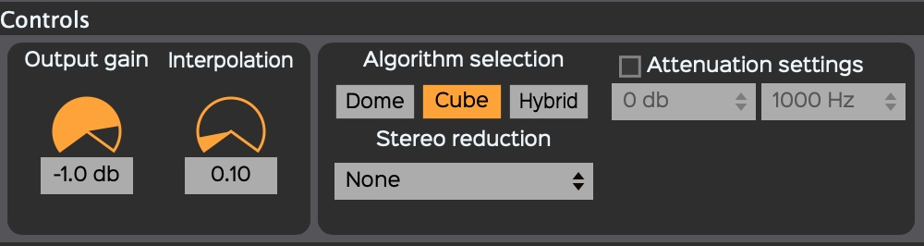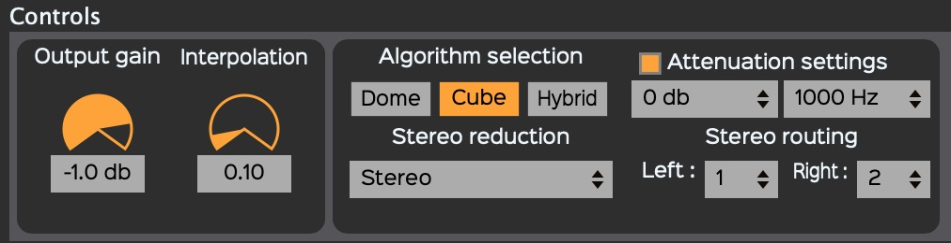

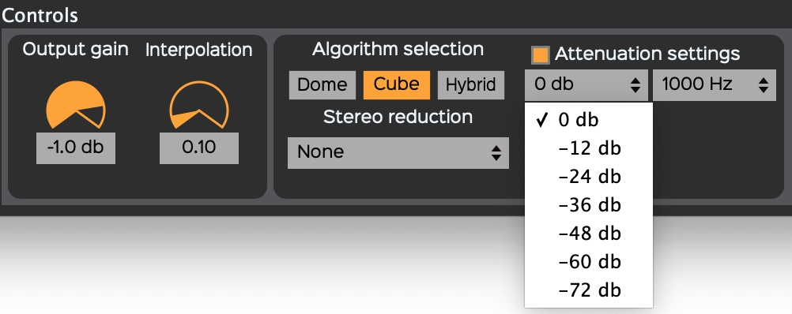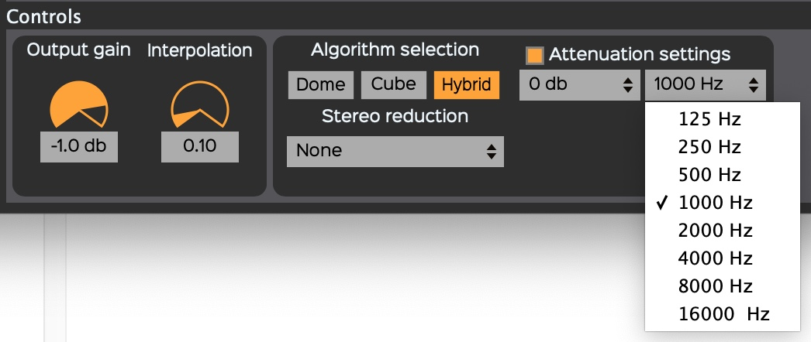

• On/Off

• Volume (dB): from 0 to -72, in -12dB steps.

• Filtering (Hz): from 125 to 16000, in octave steps.

• Volume and filtering are independent.

• In Elevation, attenuation starts at the top (Extended Top) and at the bottom (Extended Top and Bottom) of the cube.

• Attenuation settings also work in STEREO and BINAURAL mode.

NOTE: Attenuation Settings are saved within the Project.

### 5.7.4. Convert from DOME to CUBE and vice versa

In the case of switching from DOME to CUBE, *SpatGRIS* uses XYZ coordinates of the setup to maintain the integrity of the setup. This does not apply to the transition from CUBE to DOME, since in the VBAP algorithm the distance is always adjusted to 1.00. Elevation and Distance do not have the same behaviour in the DOME and CUBE algorithms. A speaker setup retains its appearance and XYZ coordinates when transitioning from the DOME algorithm to the CUBE algorithm, but not the other way around.

### 5.7.5. Spatialization in 2D and 3D

*SpatGRIS* is capable of 2D and 3D spatialization either in DOME or CUBE mode. It can be useful to use *SpatGRIS* in 2D with DAWs that are stereo-only like Ableton LiveandPro Toolsnative. Doing so gives these stereo DAWs the possibility to manage multispeaker environment like cinema standards. But of course, the real power of *SpatGRIS* lies in its 3D capabilities.

The following images present an example of a 2D speaker setup — an octophony—, and a 3D speaker setup — a cube of 24 (3x8) speakers.

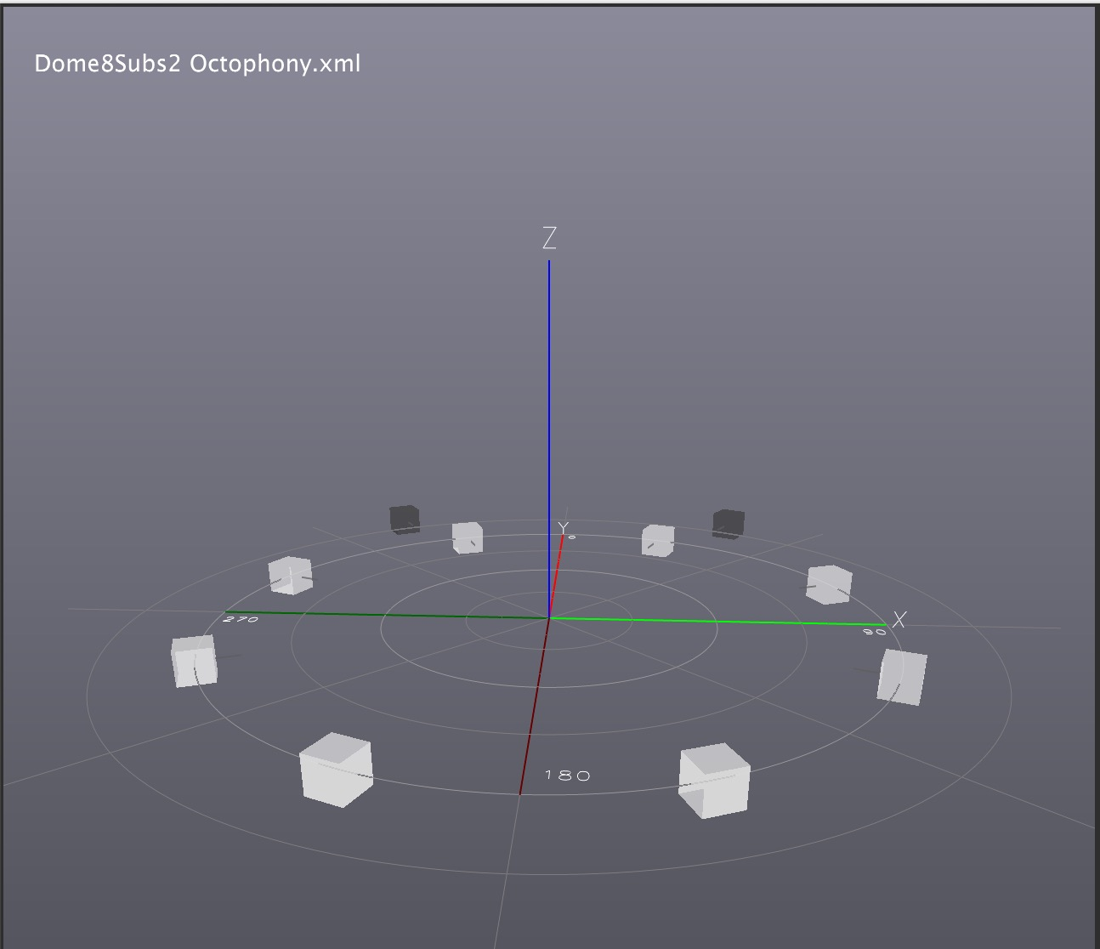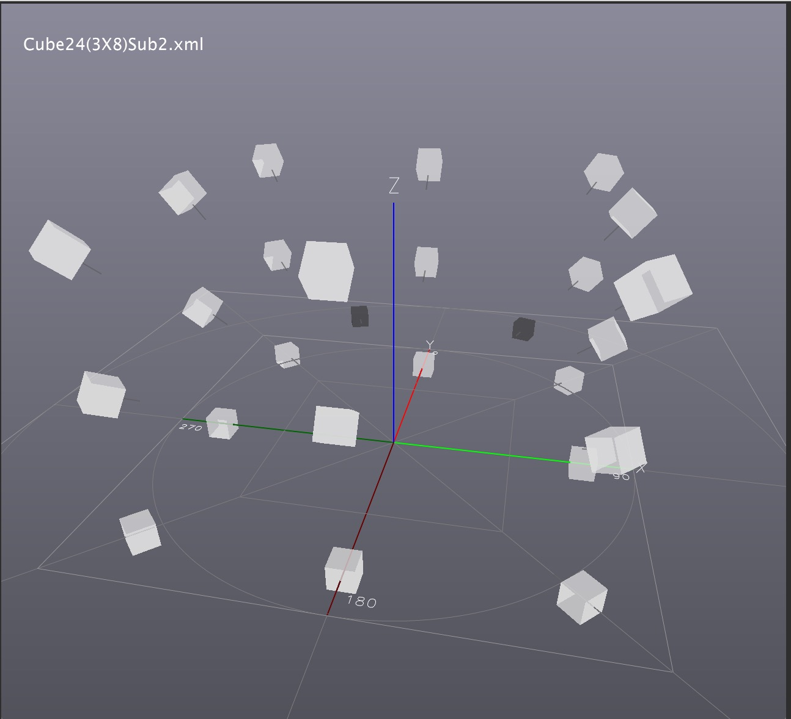

## 5.8. Speaker Setup

To design a speaker setup is the first step of the process. It is done in the *Speaker Setup Edition* window (View menu, Opt-W).

A Templates menu is provided with different speaker setups in DOME or CUBE format. The speaker setups in the Templates can’t be modified. You can use them, edit them, and save them under the name of your choice by using Save Speaker Setup As from the File menu.

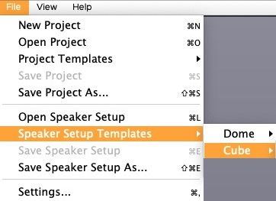

### 5.8.1. Speaker Setup Edition



Since the introduction of the MBAP (version 3.20 and up) in CUBE mode, the Global Sound Diffusion parameter allows changing the diffusion of the sound globally for the whole set of speakers. Precise localization is obtained with a small value, higher values will result with a blurred spatial image. This parameter can also influence the smoothness of trajectories.

Except for Distance which is set to 1.00 in DOME mode (by definition), speaker setup parameters can be set by polar values in DOME (Azimuth, Elevation) or by Cartesian values in CUBE (X, Y, Z). In DOME mode, Cartesian values are greyed out. In CUBE mode, polar values are greyed out.

### 5.8.2. Speakers’ order and image representation

By clicking at the top of each column (except for Gain and Highpass) in the Speaker Setup Edition window, the order of the speakers can be organized). The most important one is the Output column where you can move manually or automatically each speaker. This order will be reflected in the Speakers VU-meter ordering.

Consecutive order:

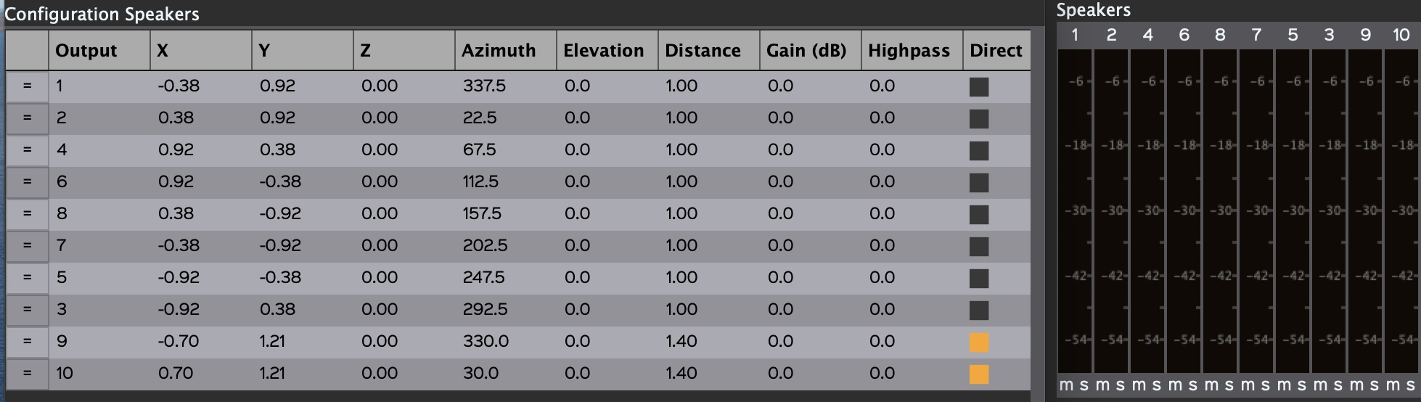

Odd and even order followed by direct outputs:

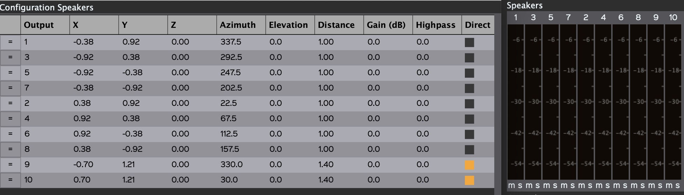

Here is an example of a speaker order that represents the actual position of the speakers in a studio with respect to the Y-axis (See 5.9.1 for more information). One can see on the speaker VU-meter section how the energy is distributed from the left to the right in the dome. The speakers 11 and 20 are in the centre, and the subs on the extreme left and right like they are placed in the studio. All the other speakers are equally distributed along the Y-axis:

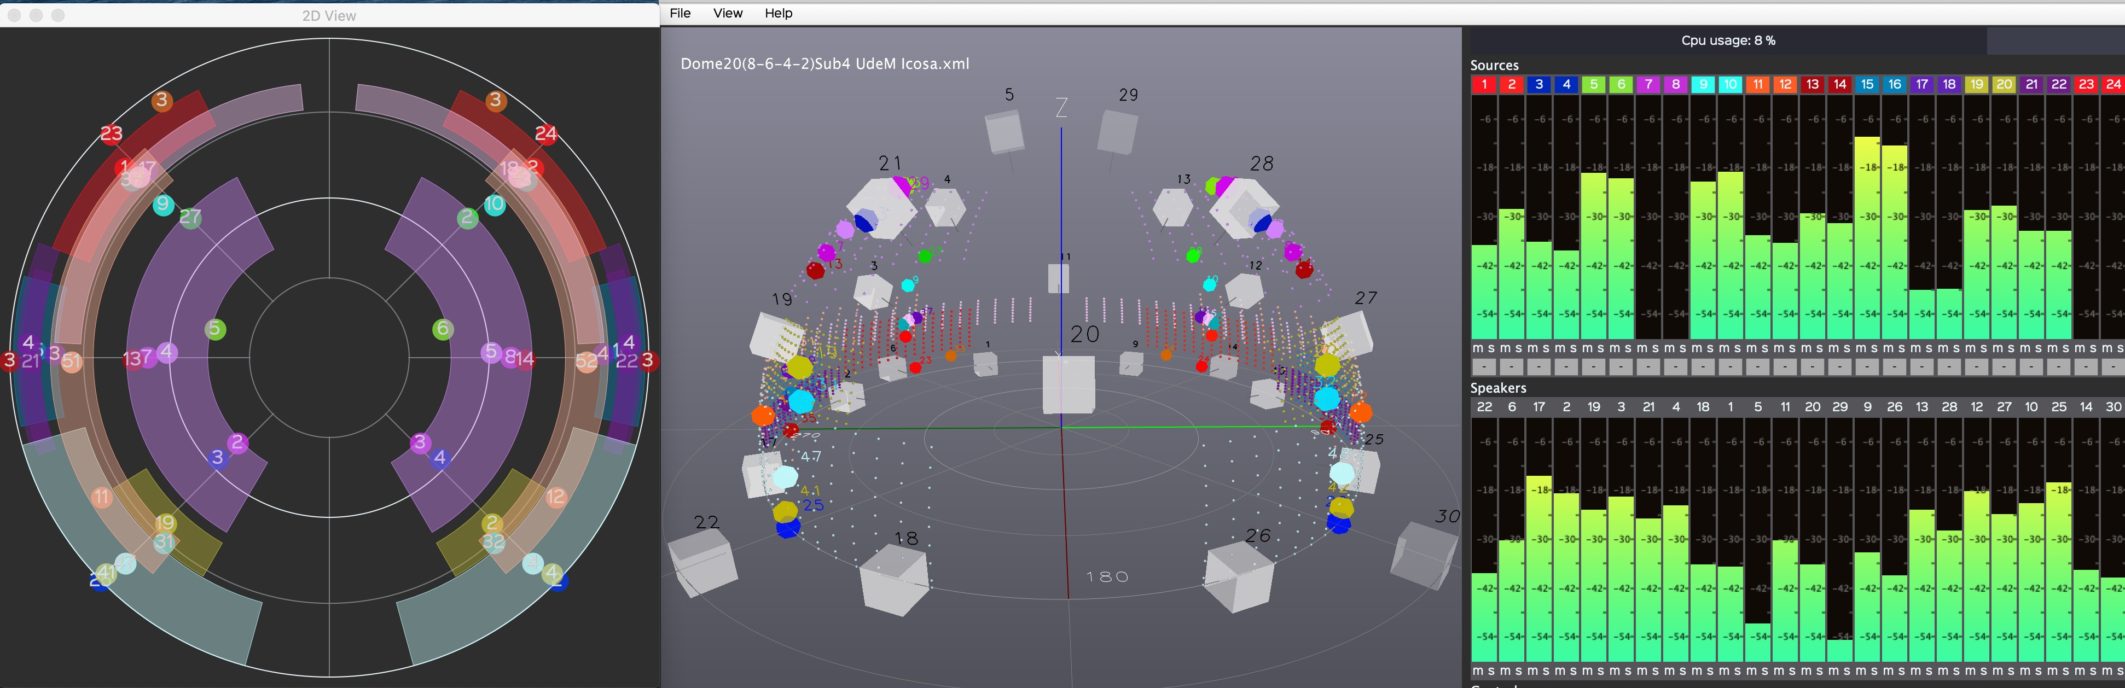

### 5.8.3. Minimal requirements

The DOME in particular needs minimal requirements to perform the VBAP calculations. If the speaker setup doesn’t fulfill them, you’ll be warned by one or two of these messages:

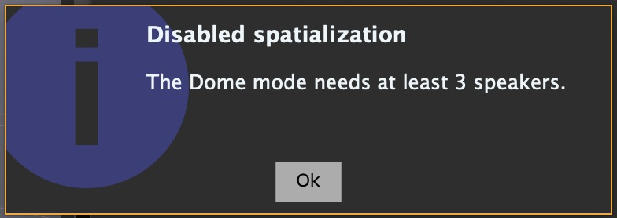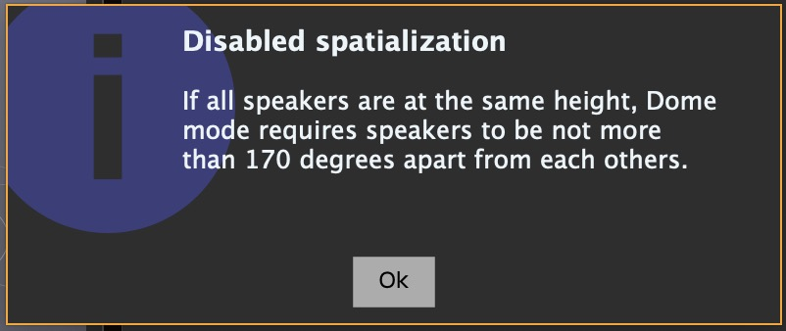

### 5.8.4. Direct outputs

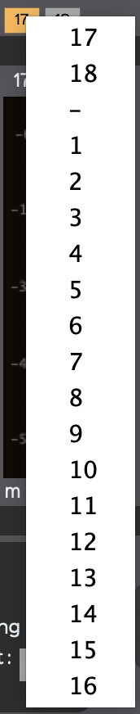A sound Source can be sent directly to a speaker via a direct output. There are two types of direct outputs in *SpatGRIS*, which was not the case before.

#### Independent direct outputs

There are independent direct outputs intended for special uses like the subwoofers. These speakers are identified with an orange rectangle in the Speaker Setup Edition window.



Their placement in the setup is not that critical, since they are independent of the spatialization, but if you intend to downmix your project in a two-channel format, their sound will be placed in the stereo image according to their left-right position. They are represented in black in the 3D SpeakerView.

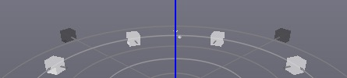

#### Spatialized direct outputs

This is a new feature in *SpatGRIS*. Any speaker in the setup can be used as a direct output and continue to be used by the spatialization algorithms. Every source has a direct output text box that is empty by default. Any speaker number can be put in there. The difference between the types of direct outputs is that independent outputs are used only for that purpose. There is no distinction in the speaker 3D view for the spatialized direct outputs.

Spatialized direct outputs were created by Samuel Béland, a major improvement of *SpatGRIS*.

One can see the distinction when selecting a direct output. The first numbers, at the top of the column (17-18) are independent direct outputs. The other numbers (1-16) can be used as a spatialized direct output.

In the following example, source 5 is sent directly to speaker 9 and source 8 to speaker 14. Both speakers 9 and 14 remains in the DOME configuration. Finally, we have sources 15-16 sent to independent direct outputs 17-18:



NOTE: Since direct outputs are assigned to specific outputs, if you open a project with different numbers of direct outputs than those in the actual speaker setup, some outputs may be muted! There is no warning for that!

### 5.8.5. Show Speaker Numbers

The location of the speakers and their numbers can be viewed in the 3D window by choosing the Show Speaker Numbers option (Opt-Z[13]). Direct outputs are shown in black. Clicking on a speaker or its number selects it; right-clicking deselects it. In the above image, speaker 3 is selected and independent direct outputs 17-18 are in black. Show Speaker Numbers only works if Show Speakers is active in the View menu.

## 5.9. Sources and Speakers

*SpatGRIS* receives audio signals from the DAW and sends them to the speakers. The two main sections are the *Sources* (from the DAW through *BlackHole*) and the *Speakers.* There are also the direct outs that are sent directly from the sources to these speakers (for subwoofers for instance).



In this example, the sources are made of 4 X octophonic sources (1-32), plus 1 X stereo source (33-34), 1 X stereo spatialized direct outputs (35-36 sent to 53-54) and 1 X independent direct output (37-38, assigned to 5-6) for a total of 38 sources identified by different groups of colours, distributed on a 32-speaker dome with 2 independent direct outs (5-6).

### 5.9.1. Mute and Solo

Each source and speaker have a *Mute* and a *Solo* button.



### 5.9.2. Peak indicators and Reset

A peak indicator is present for Sources and Speakers. There is a general Reset Meter Clipping in the view menu (Opt-M).

## 5.10. STEREO reduction

### 5.10.1. STEREO

There is a STEREO mode to listen to a complex project on a pair of speakers. All the sounds are sent to the corresponding speakers depending on their location (left to left, right to right, no front-back axis, no elevation). When STEREO is selected, the stereo routing option appears to allow you to choose the outputs of your choice, depending on your sound card. Only your sound card outputs are available for the stereo reduction. When using the computer internal sound card, the outputs are allocated to numbers 1 and 2.

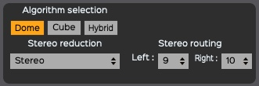

This mode can be used to downsize a multichannel project to stereo. The sources are simply placed on the Y-axis from left to right. Only the azimuth span is used in STEREO mode, not the Elevation span. Keep in mind that the sources, except for the direct outputs, are never placed directly on a speaker, but on many speakers — at least three on a DOME, many more on a CUBE. So, the projection of the sources is probably not accurate as it shows on this representation!



### 5.10.2. BINAURAL

This algorithm was implemented to help users to work on 3D spatialization from home when access to a speaker dome is limited or unavailable. It is based on a Head Related Transfer Function (HRTF). HRTF is a function that reproduces the way we perceive the localization of sounds in the space. It is a set of phase and amplitude calculations for listening on headphones. Primarily, it is designed for 5.1 reproductions or immersive listening on headphones, situations found in the gaming and the Virtual Reality industries. To minimize the number of calculations (HRTF can be very demanding in terms of computing power), *SpatGRIS* first calculates a VBAP spatialization over 16 speakers (with the BINAURAL_SPEAKER_SETUP, made invisible in this version) and then transfers the result to HRTF. Don't worry, even if your speaker setup contains more than 16 speakers, no information is lost in the process. BINAURALmodes use the stereo outputs of your choice. Both Spans are available in BINAURAL mode.

For various reasons and due to technical considerations, the output loudness of STEREO mode differs considerably from BINAURAL, mode depending on the number of sources. Please adjust your listening level accordingly.

NOTE: The Attenuation Settings used in Cube or Hybrid mode, are functional in stereo reduction.

## 5.11. Recording

When the composition of the spatialization is completed, you have two options:

1. To play the piece "live" with your DAW and *SpatGRIS*.

2. To record the spatialization to as many audio channels as the number of the speakers in the setup.

*SpatGRIS* records mono files (AIFF or WAV according to your preferences) or one interleaved file.

To record: press the big red button on the bottom right of the main window.



A pop-up window will then open, allowing you to specify:

• The location of the recorded files.

• Their name.

• The format: WAV or AIFF.

• The number of files: Mono Files or Interleaved.

• The possibility to export the Speaker Setup for the Player function (chapter 6).

Pressing the Record button will start the recording and the timer, and it will change the Record button to a blinking one. When it’s completed, you can press the Record button again to stop the recording. You can then import the separate mono files (or an interleaved file) into any DAW to play your piece in concert.

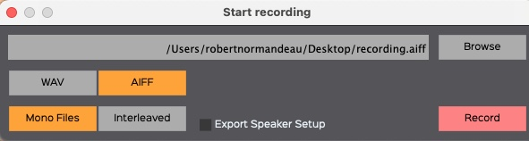

Keep in mind that with interleaved files, there are some limitations, and these limitations are reached quite rapidly on big projects:

• AIFF is limited to 2 GB.

• WAV is limited to 4 GB[14].

Also, if you record a file with many channels, you’ll find very few DAWs capable of opening it. So, it’s preferable to record Mono files.

# 6. PLAYER

*SpatGRIS*, starting with version 3.2, introduces a new tool, the PLAYER, which allows to use *SpatGRIS* as standalone software to play any piece recorded by *SpatGRIS* with any speaker setup. The main idea of the PLAYER is to help the diffusion of multichannel works among different users and on different speaker setups. Works made in DOME setup can be played in CUBE setup and vice versa. Direct outputs will be assigned automatically but can be manually adjusted afterwards.

## 6.1. To make a recording for the PLAYER

The procedure for the recording of a piece for playback with the PLAYER is almost identical to that of a normal recording. The main difference is that, in addition to recording the audio files themselves, you must export the coordinates of the used speaker setup by toggling the Export Speaker Setup function. The audio files and the speaker setup will be placed in the same folder and must remain there for the PLAYER to work properly. These coordinates will be used by the PLAYER to correctly position the sources in any given listening setup.

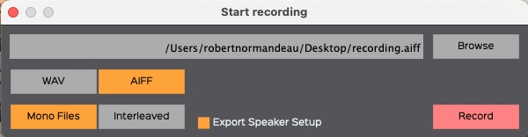

NOTE: Only mono files work with the PLAYER. You'll get an error message if you try to open an interleaved file. The reason for this is that the PLAYER uses the output numbers in the name of the audio files for the spatialization. There is no way to encode this information in an interleaved sound file.

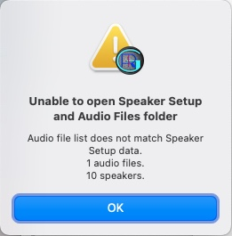

## 6.2. To open and to play a project with the PLAYER

Once the recording is done, you can send the folder that includes the sound files and the speaker setup to a listener who would use a different setup. Or you can use it yourself to play the recording on a different setup.

### 6.2.1. Open the listening speaker setup

Open the speaker setup in *SpatGRIS* on which you intend to listen to the spatialized work. It could be a custom setup or a setup from the templates.

### 6.2.2. Open the PLAYER window and load the files

View Menu —> Show Player View

Load the audio files and Speaker Setup folder:

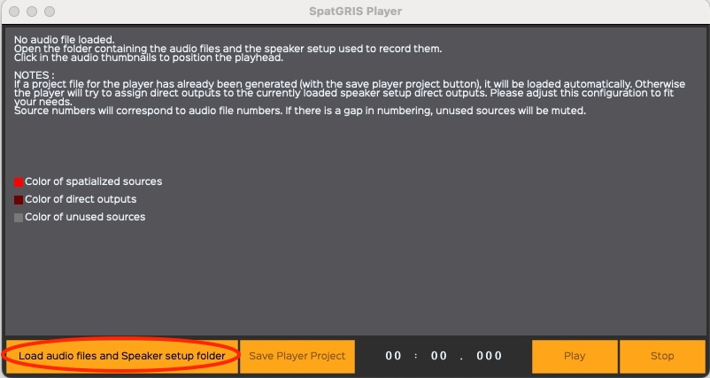

The PLAYER is now showing the basic waveform of the audio files:

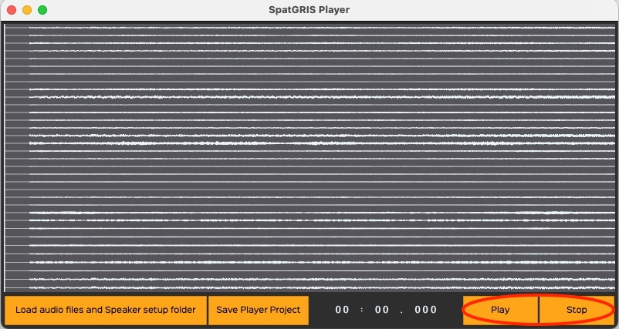

The PLAYER will also show the speaker setup with which the work was recorded. The original speaker locations are shown in red:

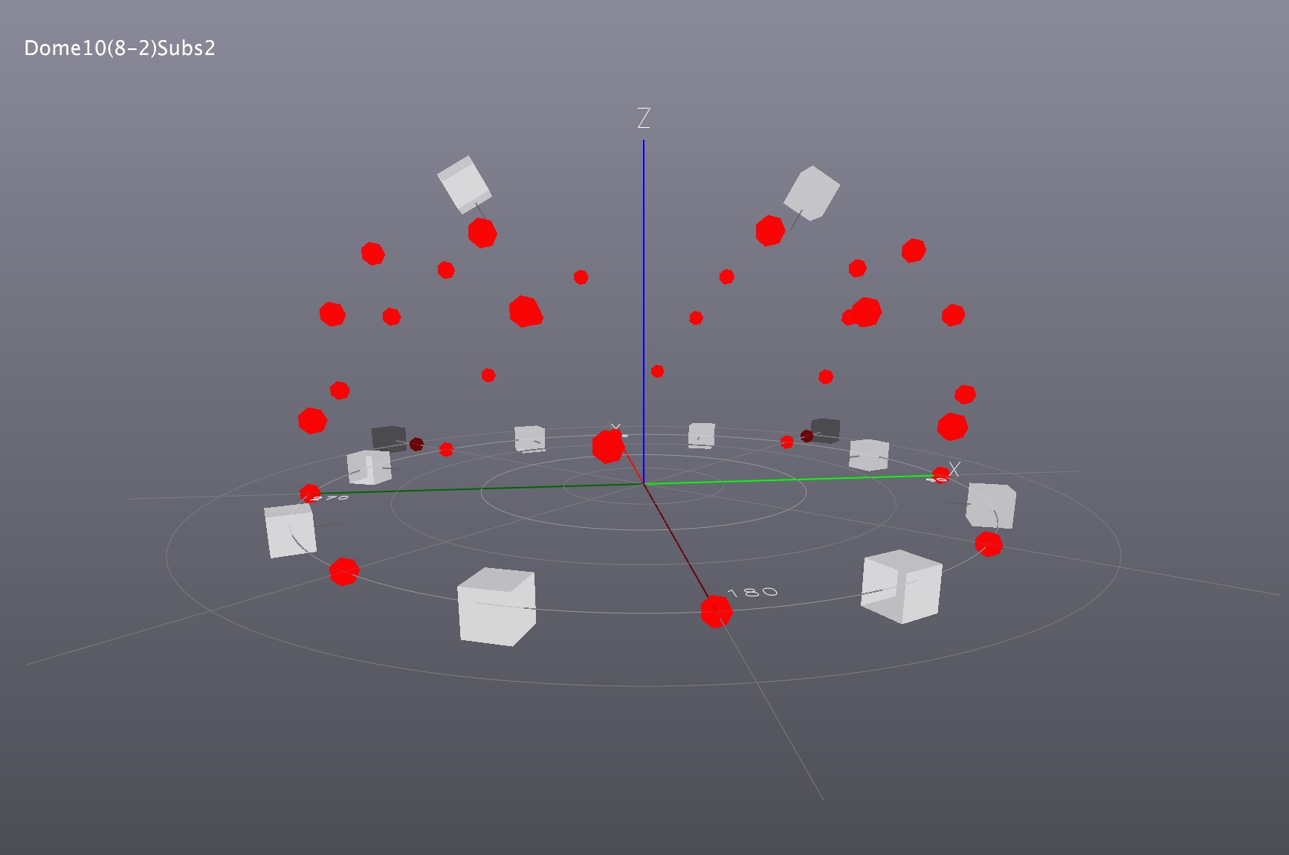

Please note that the current project loaded in *SpatGRIS* is being replaced by the project of the recording.

### 6.2.3. To play the piece

The PLAYER is now ready to play the piece. Just use the Play and Stop buttons. It's also possible to click anywhere in the soundfile to start the playback from there.

### 6.2.4. DOME in CUBE or CUBE in DOME

Here's an example of a recording made with a dome setup (Dome20(8-6-4-2)Subs4) and played within a cube setup (Cube24(2X12)Subs2). As one can see the shape of the original dome is well reproduced in the listening cube:

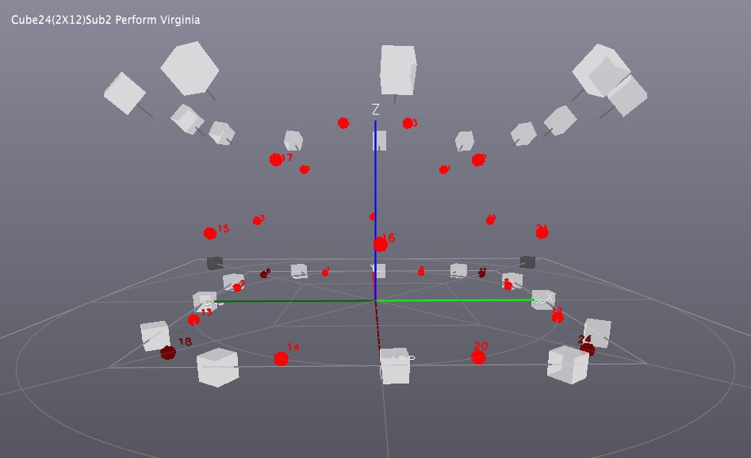

Here is another example showing the opposite situation, a cube recording (Cube24(3X8)Subs2) played within a dome (Dome20(8-6-4-2)Subs4). As one can see the shape of the original cube is well reproduced in the listening dome:

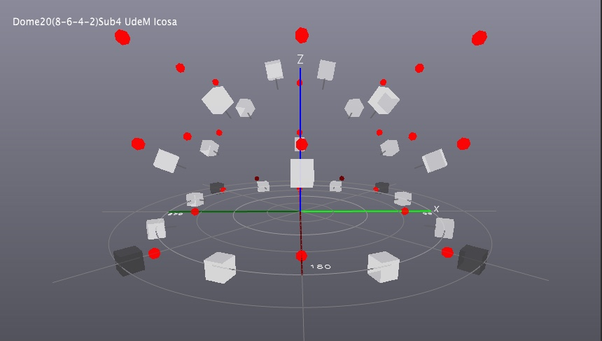

### 6.2.5. Regarding the direct outs in the PLAYER

The PLAYER will try to assign direct outputs to the currently loaded speaker setup direct outputs.

In the first previous example, the original setup had four direct outputs (numbers **6-12-18** and **24**). But in the listening setup, there are only two direct outputs (**25** and **26**). The PLAYER assigned alternatively the direct output numbers from the original to the available direct outs of the listening setup. These output numbers can be manually adjusted afterwards:

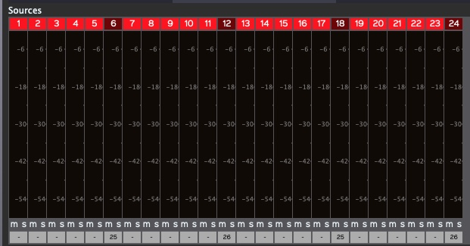

## 6.3. To save a PLAYER project

If you have changed any element in the PLAYER project, it could be saved by using the Save Player Project button. This document will be placed automatically in the same folder as the audio files and the speaker setup. The File Saved! button will blink for a while during the process. All the files should remain in the same folder. The next time you use the Load audio files and Speaker Setup folder button, everything will be placed correctly according to the way it was saved.

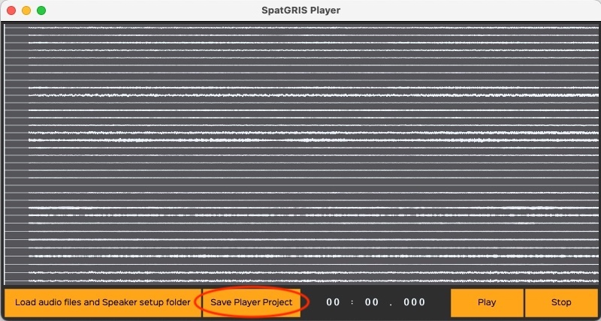

NOTE: A player project remains active until the PLAYER window is open. When you close it, SpatGRIS switches to its normal input mode, waiting for audio and OSC to come from either a sequencer or any other software.

# 7. Menus

## 7.1. File menu

In the File menu you will find all the project-related functions, where you can:

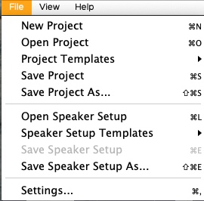

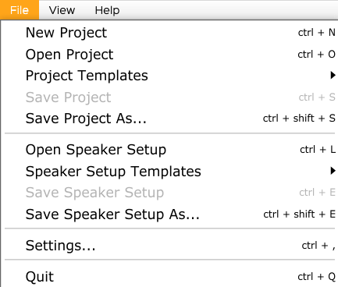• Create a New Project.

• Open an existing one.

• Open a project from the Project Templates folder. These templates can’t be modified but they can be edited and saved as a new file.

• Save Project or Save As — make a copy.

• Open a speaker setup.

• Open a speaker setup from the Speaker SetupTemplates folder. These templates can’t be modified but they can be edited and saved as a new file.

• Save Speaker Setup or Save As — make a copy.

• Open the Settings window.

## 7.2. View menu

Under the View menu, you can choose from different perspectives to visualize the speakers and sources in real time. The key modifier in this menu is Option (Opt) for Mac and Alt for Windows.

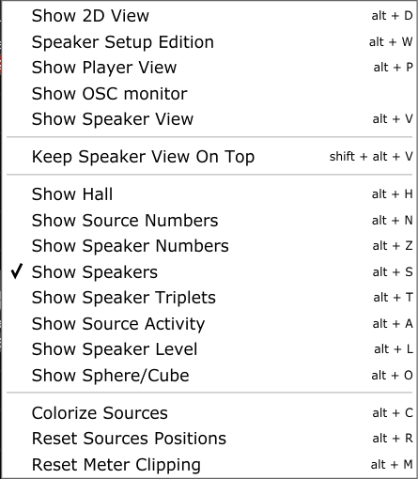• Show 2D view: A 2D view from the top of the space is given showing only the sources.

• Speaker Setup Edition: Opens a window to access all the given parameters for a valid configuration of speakers.

•Show Player View: open the Player window

• Show OSC monitor: for specialists! To help troubleshoot incoming OSC message streams.

• Show SpeakerView: open the 3D view of the speakers

—

Keep SpeakerView On Top

—

• Show Hall: show the walls of the hall

• Show Numbers: Show or hide the numbers of the displayed sources and/or speakers.

• Show Speakers: Show or hide the speakers in the 3D view.

• Show Speakers Triplets: Show or hide the triplets in the 3D view in DOME mode. There are no triplets in CUBE mode.

• Show Source Activity: This option allows to see the position and trajectories of the sources (large points) and their values for Azimuth and Elevation Span (small points), according to the data sent by the *ControlGRIS* plugin. Note that there is nothing to see when the DAW is stopped. The threshold is set at -70 dB. When this option is not selected, all sources that are part of a project are displayed, even when the DAW is stopped. This option can be useful for checking that there are no duplicate OSC channels sent from *ControlGRIS* to *SpatGRIS*.

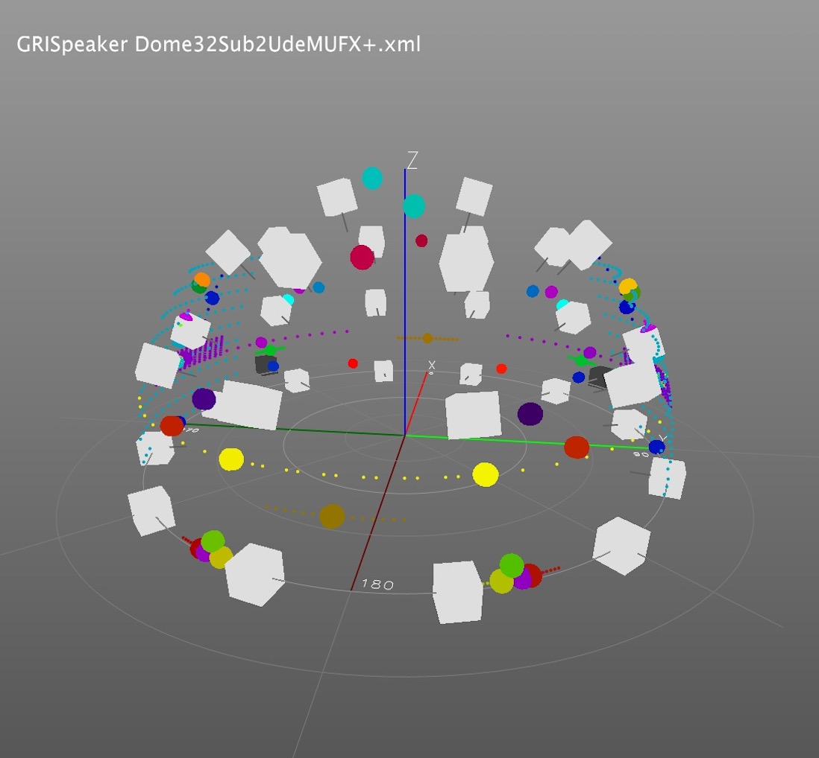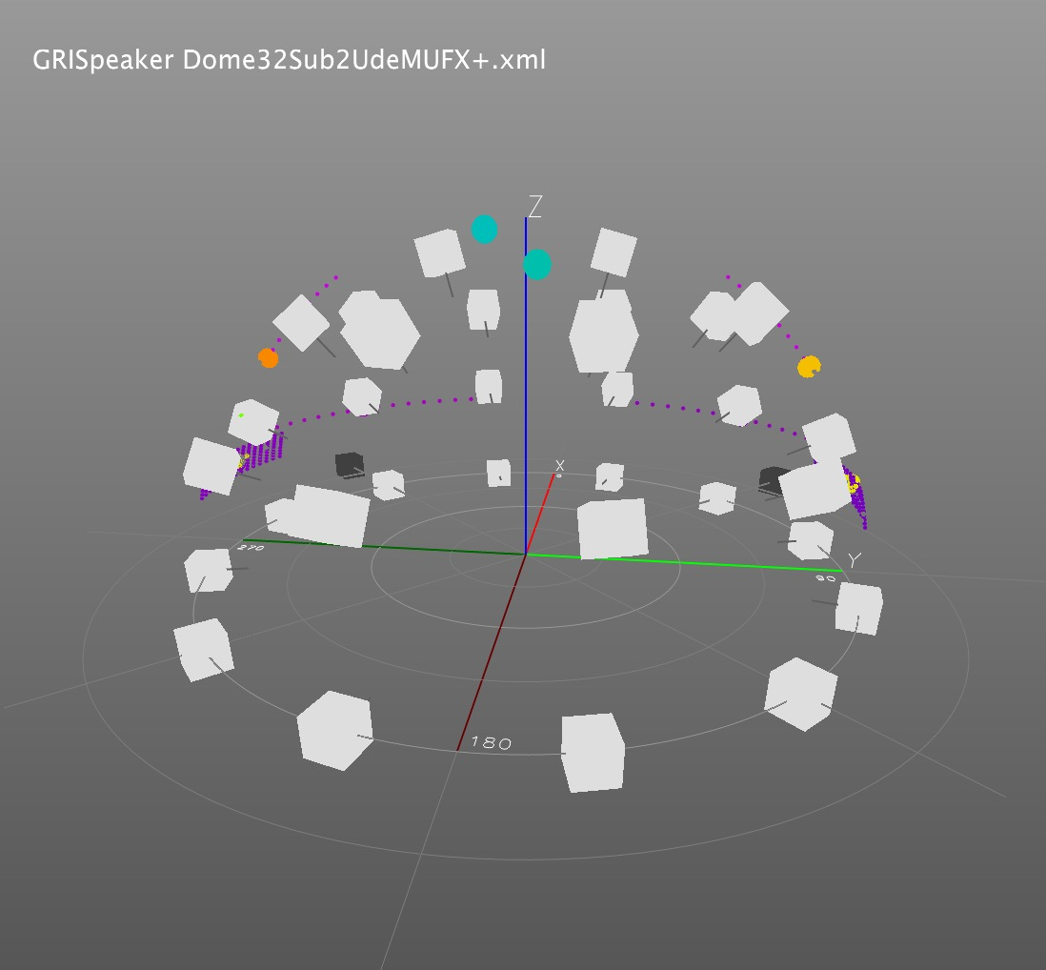

|  |  |
| --- | --- |
| *Show Source Activity* Off: shows the position of all the sources | *Show Source Activity* On: shows only the real activity of the sources in play mode |

• Show Speaker Level: Shows how much energy each speaker delivers. From grey (nothing) to white (maximum).

• Show Sphere/Cube: If you have the chance to play in a full sphere or cube!

—

• Colorize Sources: This option allows you to set all the inputs to a different colour within the visible spectra from red to purple. Be careful, it erases all the custom colours already in place.

• Reset Sources Position: When switching from a project to another, *SpatGRIS* could still show the sources from the previous project. Use this option to clear up the 3D view.

• Reset Meter Clipping: clipping indicators can be reset individually by clicking on them, or globally with Opt-M shortcut.

## 7.3. Naming and Saving

There are three sections in *SpatGRIS* that are saved independently: Project, Speaker Setup and Settings.

• Save Project. A project is coupled with a work.

• Save Speaker Setup. A speaker setup is coupled to an installation placed in a space.

• Save Settings. User settings are linked to a workstation — computer and audio interface — including the stereo outputs used for stereo reduction (even without showing it)

• Save Settings. The stereo outputs are coupled to a specific audio interface.

Speaker setups and Project documents are saved under the .xml format. There is no distinction between them. The Project document doesn't include the speaker setup and they are therefore independent. Consequently, we strongly recommend two things:

• Add the word "Speaker Dome" or " Speaker Cube" to the name of your speaker setups and "Project Dome", "Project Cube" or "Project Hybrid" to the name of your project files.

• Save the DOME or the CUBE speaker setups in two separate folders in a folder named *Speaker*s.

• Save *SpatGRIS* projects in three separate folders inside a folder named *Projects.*

The Templates menus we provide with *SpatGRIS* is a good example of the right classification.

• Document format warnings

*SpatGRIS* always remembers the last opened speaker setup and the last project.

If you try to open a *SpatGRIS* project with the command Load Speaker Setup (or the opposite), you'll be warned:

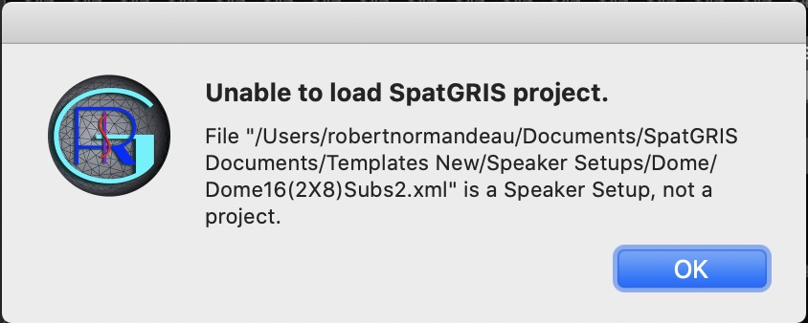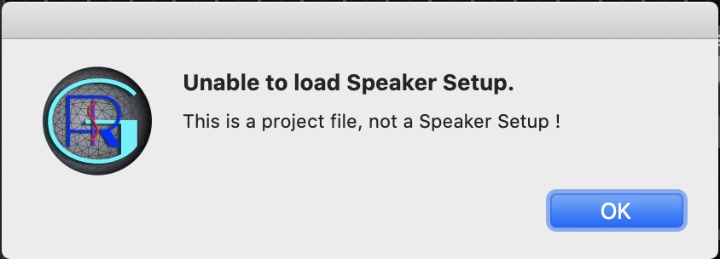

NOTE: SpatGRIS documents adopt a new format and are not backward compatible with older versions of SpatGRIS. By trying to open a SpatGRIS project or a speaker setup from the version 2, you’ll get one of these scary messages! Your files are OK, just not compatible:

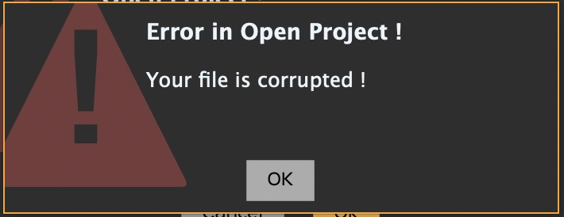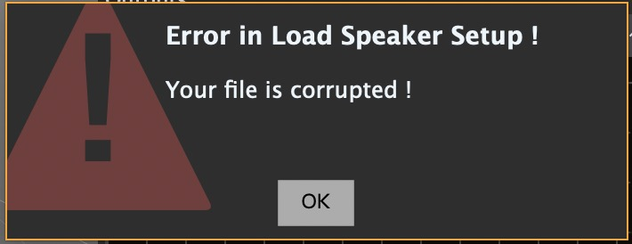

## 7.4. Representations

The 3D and 2D views in *SpatGRIS* are available for both DOME and CUBE modes. The sources on the DOME are on the surface and the Spans spread along that surface. In CUBE mode, the sources can be placed anywhere in the space and the Spans spread locally around the sources.

### 7.4.1. 3D Representation

The 3D window in DOME mode (left) or in CUBE mode (right) of the same session. Speakers and Sources are represented:

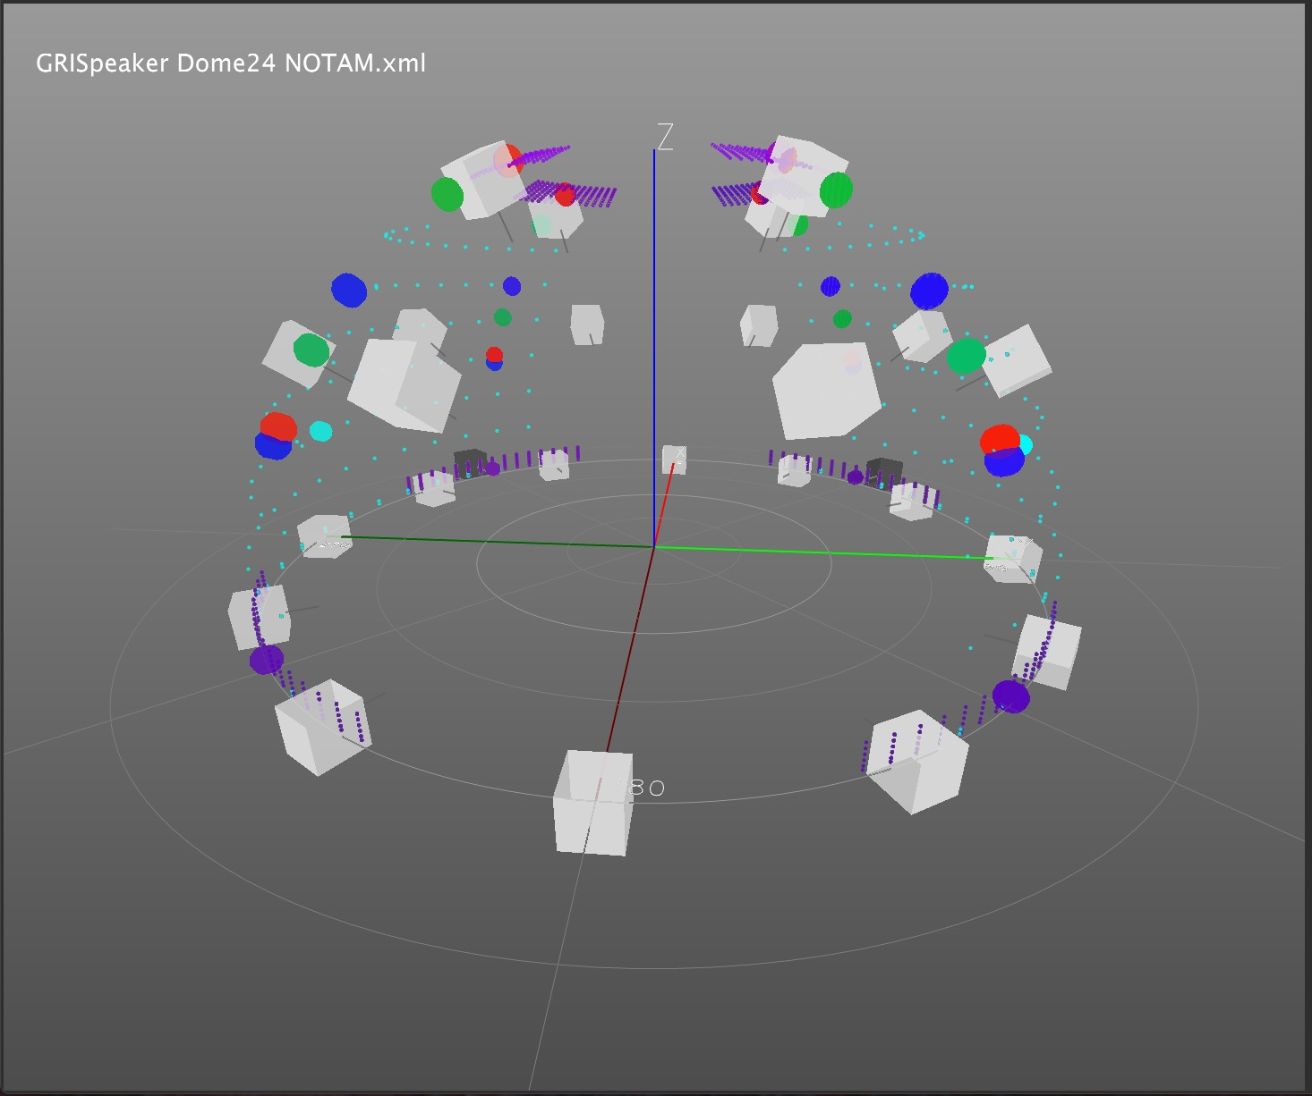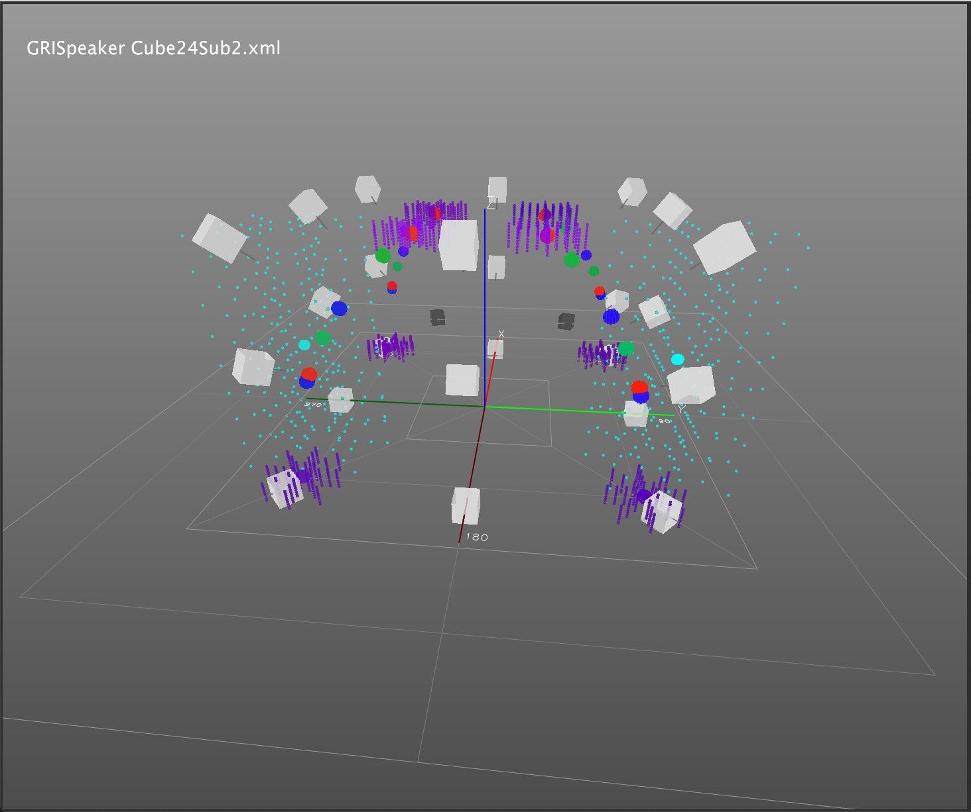

### 7.4.2. 2D Representation

The 2D view in DOME mode (left) or in CUBE mode (right) of the same session. Only Sources are represented:

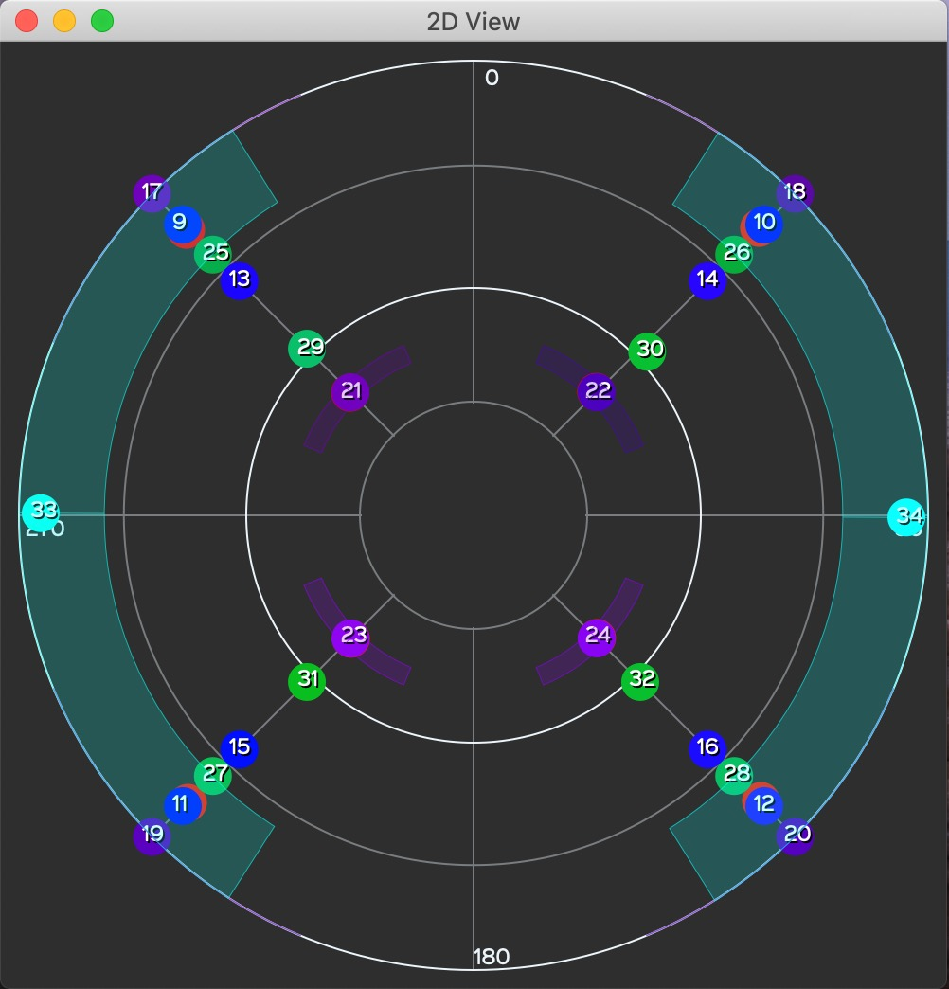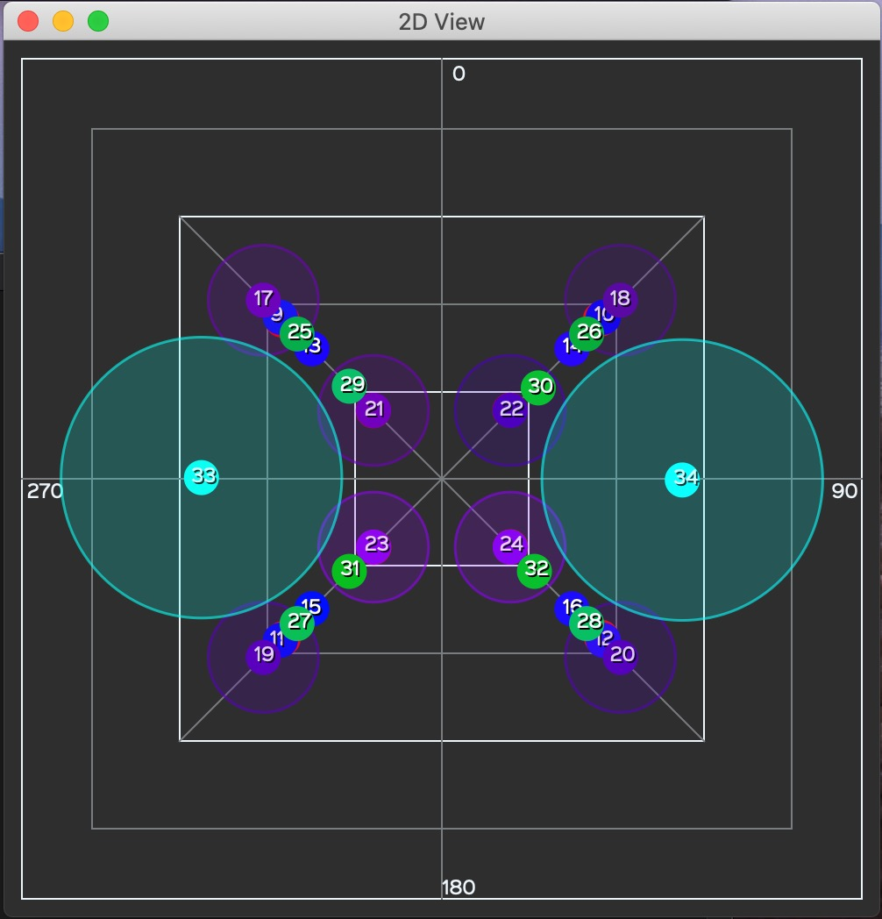

## 7.5. Performance and CPU burst

The performance of the *ControlGRIS*/*SpatGRIS* combination largely depends on the different settings in your project. As a rule, a project with 64 audio channels sent to 64 speakers will work perfectly well on recent computers. We have tested projects with more than 100 audio channels over a 256-speaker setup and that was still working well!

The factors which will significantly augment the CPU usage needed by our tools are, in order of importance:

• The Mode: CUBE is more demanding than DOME, since the former uses more speakers than the latter.

• The Spans: they distribute the signal to more speakers than when they are not in use, and therefore the CPU demand increases very rapidly as their values increase.

• The Interpolation: the interpolation factor helps some sounds to achieve a more fluid transition time as they move from one place to the next. Therefore, the higher this parameter, the higher the number of speakers involved in the process, since a sound will reach a given speaker earlier and take more time to leave it (not to mention, it also blurs the localization).

• The number of speakers used in *SpatGRIS*. We measured comfortable performance with a 96-speaker setup, which is largely enough in most realistic situations!

• The number of tracks multiplied by the number of speakers determines the reliability of the setup. Few tracks over a big speaker setup will give the same result as many tracks over a small speaker setup.

If the CPU overpass 100%, this is the warning you'll get this alert:

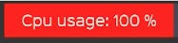

Want to know what to expect? Try it for yourself!

## 7.6. Help Menu

The Help menu comprises information about the GRIS and this manual, under the Open Documentation option.



**Take the plunge and have fun!**

# 8. Addendum

## 8.1. Sources Link descriptions

### 8.1.1. Azimuth-Elevation and Azimuth-Distance

|  |
| --- |
| **1) Independent** MONO + STEREO + MULTIPHONIC |
| This mode is selected by default. The sources can be moved independently from one another. |
| **2) Circular** STEREO + MULTIPHONIC |
| This mode enables the circular grouped movement. The angles between the sources remain constant while the radius adjusts proportionally. |
| **3) Circular Fixed Radius** STEREO + MULTIPHONIC |
| The sources are linked in a circular motion by the Radius parameter, which remains fixed and equal. The relative distance between each source and the centre is the same for all sources. |
| **4) Circular Fixed Angle** STEREO + MULTIPHONIC |
| The sources are linked in a circular motion with the Angle parameter, which remains fixed and equal.  For example, in octophony the opening angle between each of the sources will be fixed to 45°. |
| **5) Circular Fully Fixed** STEREO + MULTIPHONIC |
| The sources are linked in a circular motion by both the Radius and Angle parameters, which remain fixed and equal. The opening between the sources and their radius is therefore always identical. |
| **6) Delta Lock** STEREO + MULTIPHONIE |
| This mode locks the position of the sources in relation to others along the X and Y axes, without the possibility of rotation. |

|  |
| --- |
| **7) Symmetric X** STEREO |
| This mode enables the symmetry between two sources following the X axis. |
| **8) Symmetric Y** STEREO |
| This mode enables the symmetry between two sources following the Y axis. |

### 8.1.2. Elevation (CUBE mode only)

|  |
| --- |
| **1) Independent** MONO + STEREO + MULTIPHONIC |
| This mode is selected by default. The sources can be moved independently from one another. |
| **2) Fixed Elevation** STEREO + MULTIPHONIC |
| Same elevation for each source. |
| **3) Bottom Top** STEREO + MULTIPHONIC |
| This mode locks the position of the sources from a minimum to a maximum value in a linear relationship. |
| **4) Top Bottom** STEREO + MULTIPHONIC |
| This mode locks the position of the sources from a maximum to a minimum value in a linear relationship. |

|  |
| --- |
| **5) Delta Lock** STEREO + MULTIPHONIC |
| This mode locks the position of the sources in relation to others. |

## 8.2. Trajectory descriptions

### 8.2.1. Azimuth-Elevation and Azimuth-Distance

|  |
| --- |
| **1) Circle** |
| Circular motion around the centre.  Options: CW/CCW, Back & Forth, Dampening, Deviation. |
| **2) Ellipse** |
| Elliptical motion around the centre.  Options: CW/CCW, Back & Forth, Dampening, Deviation. |
| **3) Spiral** |
| Concentric motion around the centre.  Options: CW/CCW, Back & Forth, Dampening, Deviation. |
| **4) Square** |
| Square shape around the centre.  Options: CW/CCW, Back & Forth, Dampening, Deviation. |
| **5) Triangle** |
| Triangle shape around the centre.  Options: CW/CCW, Back & Forth, Dampening, Deviation. |

### 8.2.2. Elevation (CUBE mode only)

|  |
| --- |
| **1) Down Up** |
| From the bottom to the top.  Options: Back & Forth, Dampening. |
| **2) Up Down** |
| From the top to the bottom.  Options: Back & Forth, Dampening |

## 8.3. OSC messages in SpatGRIS

OSC can be sent directly to *SpatGRIS* without having to use *ControlGRIS*.

OSC Input port number: 18032 by default (can be changed in File -> Settings)

The server address is always /spat/serv.

**Please note that angles are always measured clockwise, starting from the upstage centre (the positive Y direction).**

**pol** moves a source using polar coordinates in radians.

| **#parameter** | **type** | **allowed values** | **meaning** |
| --- | --- | --- | --- |
| 1 | string | pol | - |
| 2 | int | [1, 256] | Source index |
| 3 | float | any | azimuth angle |
| 4 | float | any | elevation angle |
| 5 | float | [-3.0, 3.0] | radius |
| 6 | float | [0, 1] | Horizontal span |
| 7 | float | [0, 1] | Vertical span |

ex : The message /spat/serv pol 7 0.0 0.78 0.5 0.1 0.2 moves the source #7 in the front at half elevation and placed at half the distance from the origin, with an horizontal span of 10% and a vertical span of 20%.

**deg** moves a source using polar coordinates in degrees.

| **index** | **type** | **allowed values** | **meaning** |
| --- | --- | --- | --- |
| 1 | string | deg | - |
| 2 | int | [1, 256] | Source index |
| 3 | float | any | azimuth angle |
| 4 | float | any | elevation angle |
| 5 | float | [-3.0, 3.0] | radius |
| 6 | float | [0, 1] | Horizontal span |
| 7 | float | [0, 1] | Vertical span |

ex : The message /spat/serv deg 7 -90.0 45.0 0.5 0.1 0.2 moves the source #7 at the extreme left, at half elevation and half the distance of the space, with an horizontal span of 10% and a vertical span of 20%.

**car** moves a source using Cartesian coordinates.

| **index** | **type** | **allowed values** | **meaning** |
| --- | --- | --- | --- |
| 1 | string | car | - |
| 2 | int | [1, 256] | Source index |
| 3 | float | [-1.66, 1.66] | x (left/right) |
| 4 | float | [-1.66, 1.66] | y (back/front) |
| 5 | float | [-1.66, 1.66] | z (down/up) |
| 6 | float | [0, 1] | Horizontal span |
| 7 | float | [0, 1] | Vertical span |

ex : The message /spat/serv car 7 1.0 1.0 1.0 0.0 0.0 moves the source #7 at the top right corner, with no horizontal or vertical spans.

**clr** clears a source's position.

| **index** | **type** | **allowed values** | **meaning** |
| --- | --- | --- | --- |
| 1 | string | clr | clear |
| 2 | int | [1, 256] | Source index |

ex : The message /spat/serv clr 7 clears the seventh source's position.

**alg** sets a source's hybrid spatialization mode.

| **index** | **type** | **allowed values** | **meaning** |
| --- | --- | --- | --- |
| 1 | string | alg | - |
| 2 | int | [1, 256] | Source index |
| 3 | string | dome or cube | Algorithm |

ex : The message /spat/serv alg 7 cube sets the seventh source's spatialization algorithm to "cube" (only works in hybrid mode).

## 8.4. OSC messages in ControlGRIS

There are the OSC messages that *ControlGRIS* can send and receive. The first number corresponds to the plugin ID. The second number corresponds to the source number. These are the default values:

• /controlgris/1/traj/1/x value => [0.0;1.0]

• /controlgris/1/traj/1/y value => [0.0;1.0]

• /controlgris/1/traj/1/z value => [0.0;1.0]

• /controlgris/1/traj/1/xyz/1 value => [0.0;1.0]

• /controlgris/1/traj/1/xyz/2 value => [0.0;1.0]

• /controlgris/1/traj/1/xyz/3 value => [0.0;1.0]

• /controlgris/1/traj/1/xy values => [0.0;1.0] [0.0;1.0]

• /controlgris/1/traj/1/xyz values => [0.0;1.0] [0.0;1.0] [0.0;1.0]

• /controlgris/1/azispan value => [0.0;1.0]

• /controlgris/1/elespan value => [0.0;1.0]

• /controlgris/1/sourcelink value => 1 to 8

1: Independent

2: Circular

3: Circular Fixed Radius

4: Circular Fixed angle

5: Circular Fully Fixed

6: Delta Lock

7: Symmetrix X

8: Symmetric Y

• /controlgris/1/sourcelinkalt value => 1 to 5

1: Independent

2: Equal Elevation

3: Bottom-Top

4: Top-Bottom

5: Delta Lock

• /controlgris/1/presets value => 1 to 50

• /controlgris/1/elevationmode value => 1 to 3

1: Normal

2: Extended Top

3: Extended Top and Bottom

## 8.5. Open Stage Control and Lemur

Two external controllers are available for *ControlGRIS*:

• An Open Stage Control patch for iPad™.

• A Lemur patch for iPad™.

An Addendum manual concerning these patches is available on SourceForge.

## 8.6. Uninstall

### 8.6.1. SpatGRIS

If you need to uninstall *SpatGRIS*, or if you find some strange behaviour of the software, you'll have to do so manually.

• Put the application itself in the trash.

• Put these files to the trash:

~/Library/Preferences/ca.umontreal.musique.gris.spatgris.plist

~/Application Support/GRIS/ SpatGRIS.x.x.xml where x.x.x is the version of *SpatGRIS* (3.2.1 for instance).

### 8.6.2. ControlGRIS

If you need to uninstall *ControlGRIS*.

Here are the paths for Mac users:

• To uninstall the Audio Unit version, delete it from the following location: ~/Library/Audio/Plug-Ins/Components

• To uninstall the VST version, delete it from the VST folder to the following location: ~/Library/Audio/Plug-Ins/VST

• To uninstall the VST3 version, delete it from the VST3 folder to the following location: ~/Library/Audio/Plug-Ins/VST3.

• To uninstall the AAX version, delete it from the following location: MacIntosh HD/Library/Application Support/Avid/Audio/Plug-Ins/

# 9. Known issues and warnings

There are so many different situations and setups that it would be impossible for us to cover them all. So far, we haven't found any situation where the system does not work at all. But we have found situations where some parameters must be adjusted before the system works properly. Here are a few of them.

## 9.1. Known issues

### 9.1.1. SpatGRIS, Mac version only.

We have a couple of graphical issues with the Apple Silicon machines.

• Issue #378 (Github): When using the 'Show Speaker Level' function on M1 and M2, the speakers are not visible unless an audio signal is sent to them.

• Issue #344 (Github): Unable to zoom out in the 3D display after a maximum zoom in, only with Mac M1.

Both these issues are currently under review and should be resolved soon.

### 9.1.2. ControlGRIS

• The usage of the Back & Forth option leads to many different and unpredictable behaviours that vary according to the DAW and the kind of tracks — audio, MIDI, Aux or Instruments — in which *ControlGRIS* is inserted (Issue # 94).

• *ControlGRIS* is in an intensive process of refurbishment at the moment. Stay tuned!

### 9.1.3. SpatGris, the plugin and SpatGRIS, the software

For those who used the plugin *SpatGris1*, you’ll notice that it isn't working anymore on most recent macOS and on the Apple Silicon machines. We recommend switching to *ControlGRIS*. The development of *SpatGris* ended in 2018.

## 9.2. Reaper

### 9.2.1. Mono tracks

• Create a track and insert an instance of *ControlGRIS* and a mono audio file into it.

• Click on the Route button located to the right of the track gain adjustment knob.

• In the window that opens, uncheck Master send.

• At the bottom left of this same window, click on the Add new hardware output…

• At the very bottom of the list of outputs on the output interface are the individual, mono outputs.

• Select the output that corresponds to the number assigned to the source in *ControlGRIS*.

There is no need to pan mono sources to the left for odd tracks and to the right for even tracks, since you don't have to choose the stereo outputs of Blackhole. Also, currently the Master track in Reaper is limited to 128 channels, so it is convenient to use the Reaper hardware outputs directly as described.

### 9.2.2. Device Preferences with Jack

In the Preferences of Reaper, under Audio tab: uncheck *Close audio device when stopped and application is inactive*. Otherwise, *Jack* will lose contact with Reaper when it is inactive, and the system will never work.

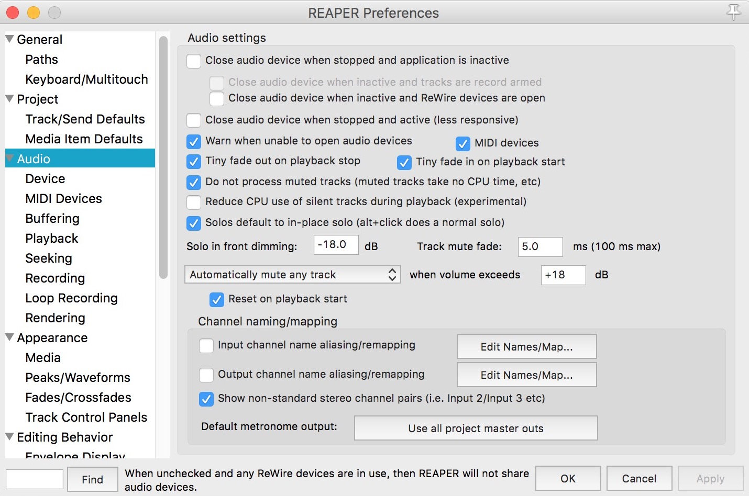

## 9.3. Logic Pro

### 9.3.1. Only one Surround output

In Logic Pro, there is only one possible *Surround* instance. This means that it is not possible to have multiple multichannel tracks in Logic Pro while using *SpatGRIS*. To avoid this restriction, use only mono and stereo tracks in Logic Pro.

### 9.3.2. Activate buttons

When using *ControlGRIS* predefined trajectories, there is an exception about the activate button in Logic Pro. If there is no more audio in the track at the stop position, the *Activate* buttons will not turn to off. They will have to be deactivated manually.

## 9.4. Digital Performer 11 and Automated presets

The recorded presets in DP show soft curves instead of the square expected ones. It means that changing from one automated preset to the next is very smooth and progressive, where it’s expected to be drastic. We are working on that.

## 9.5. Using SpatGRIS with live inputs

When using live inputs, we recommend using the Aggregate Device on a Mac. According to our tests, the system is stable when you create an aggregate device comprising *BlackHole* and the sound card you're using. This aggregate device must be designated as the audio input and output device in your DAW and as the audio input and output device in *SpatGRIS*.

For channel numbering, please refer to the Audio / Midi Configuration application on your Mac once you have created your aggregated device. By placing your physical sound card as the first device element, you won't need to change the numbering of speaker configurations. This workflow has been tested with Ableton Live.

For Windows use, using *Jack* seems sufficient, but we haven't tested it in depth.

NOTE: Adjust the Buffer size to the same value, both in your DAW and SpatGRIS. A value of 256 and up is recommended.

# 10. Tips and Tricks

In addition to the normal use of SpatGRIS for programming the spatialization of sound from a wide variety of sources, here are a few examples of other uses that might not immediately spring to mind. Over the years, these uses have emerged through the inventive practices of our users.

## 10.1. Acousmatic spatialisation

It is perfectly possible to use SpatGRIS in the context of traditional acousmatic spatialization, where a stereophonic source is multiplied over as many pairs of loudspeakers in the concert hall. We have used it in this way for years during the weekly concerts in the History of Electro Music course.

### 10.1.1. Mixing console

To achieve spatialization in an acousmatic context, you need a mixing console with Ethernet transmission (ideal, like an AVID S1 or an Euphonix) or MIDI (slower, like a Mackie Control or a Behringer).

### 10.1.2. Digital Audio Workstation

In the DAW of your choice (DP, Logic, Live, Nuendo, Reaper, etc.), you place the stereo audio file on the first stereo track, on which you also place a ControlGRIS plug-in. You then multiply copies of this first stereo track on as many additional copies as your spatialization scenario requires. It's also possible to have just one audio track and as many auxiliary outputs as you need, if your SAN allows. Each track and each instance of ControlGRIS will be assigned consecutive numbers. It's important to mention here that we're not talking about one potentiometer = one loudspeaker. Each loudspeaker can be used for several **spatialization** scenarios

### 10.1.3. Acousmatic setup

Let's use the Dome24(8-5x2-6)Subs2 Acousmonium setup present in the SpatGRIS Templates. This consists of:

• 1 octophonic, from 1 to 8

• 1 asymmetric pair on the left 9-10 (direct outputs)

• 1 central solo pair 11-12 (direct outputs)

• 1 main stereo pair 13-14 (direct outputs)

• 1 pair centre-right asymmetric 15-16 (direct outputs)

• 1 asymmetric pair on the left 17-18 (direct outputs)

• 1 hexaphonic group 19 to 24

• 1 pair of subwoofers 25-26 (direct outputs)

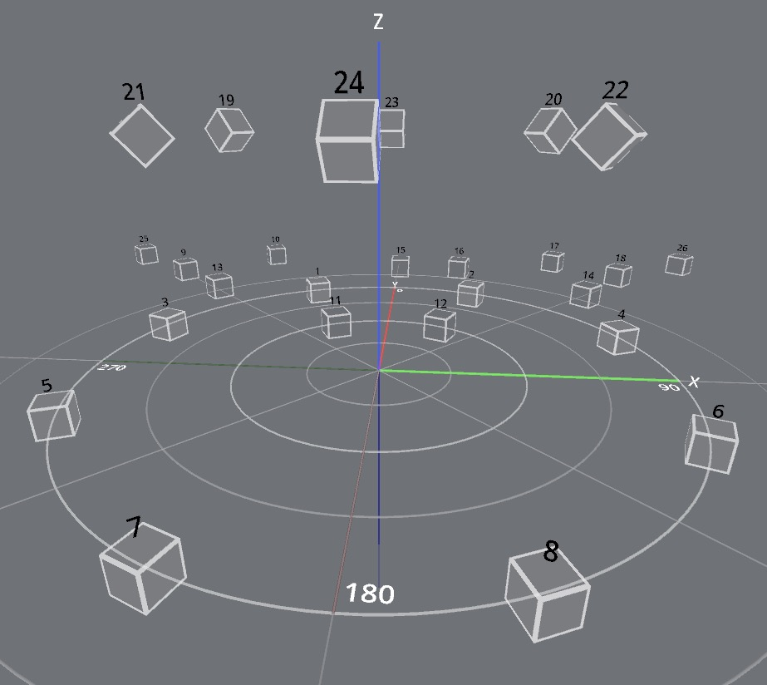

### 10.1.4. Scenario

The first scenario would involve assigning each potentiometer to a loudspeaker group in the order mentioned above. This requires 8 potentiometers, as there are 8 loudspeaker groups. Direct outputs do not need ControlGRIS.

• Potentiometer 1: ControlGRIS 1-2, BlackHole audio outputs 1-2, Left-Right position, Azimuth Span at 50%.

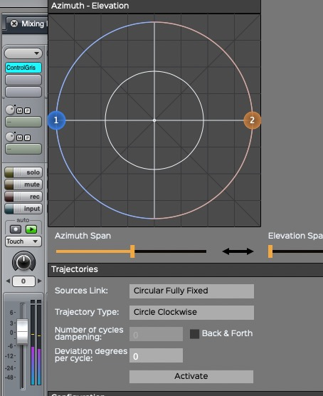

In this way, the stereo source is fully distributed over the 8 hp of the octophonic group.

The left channel on the odd-numbered speakers (in pale turquoise) and the right channel on the even-numbered speakers (in darker turquoise):

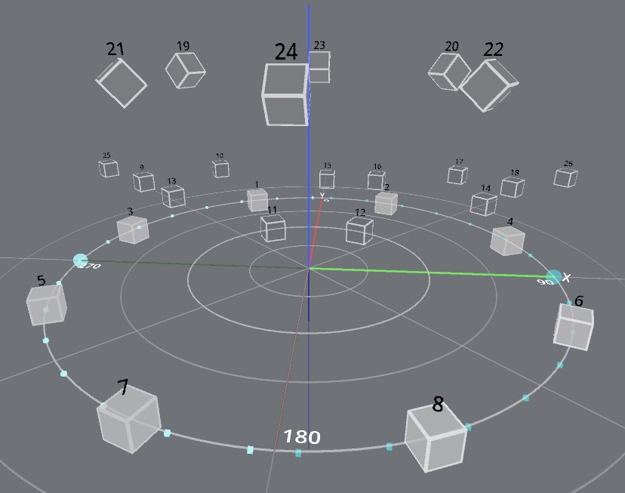

• Potentiometer 2: no ControlGRIS, BlackHole outputs 3-4, H-P 9-10 direct outputs in SpatGRIS (in black):

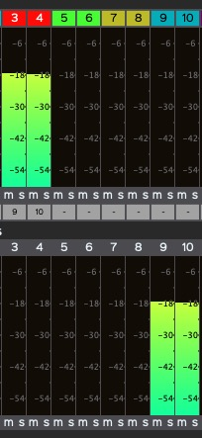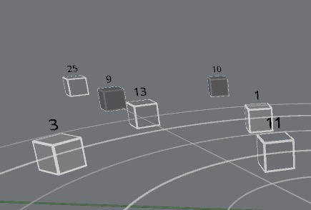

• Potentiometer 3: no ControlGRIS, BlackHole outputs 5-6, H-P 11-12 direct outputs in SpatGRIS (in black):

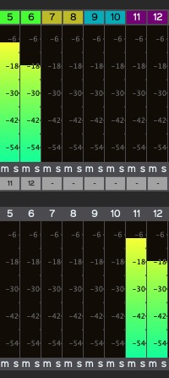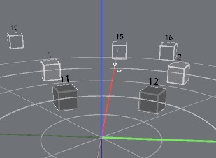

• Potentiometer 4: no ControlGRIS, BlackHole outputs 7-8, H-P 13-14 direct outputs in SpatGRIS (in black):

Same scenario

• Potentiometer 5: no ControlGRIS, BlackHole outputs 9-10, H-P 15-16 direct outputs in SpatGRIS (in black):

Same scenario

• Potentiometer 6: no ControlGRIS, BlackHole outputs 11-12, H-P 17-18 direct outputs in SpatGRIS (in black):

Same scenario

• Potentiometer 7: ControlGRIS 13-14, BlackHole outputs 13-14, H-P 19-24 Left-right position, Azimuth Span at 50%, Elevation at top of dome:

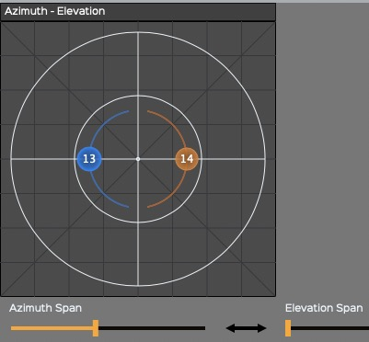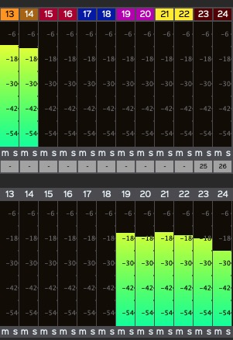

The left channel on odd-numbered hp (in light orange) and the right channel on even-numbered hp (in darker orange):

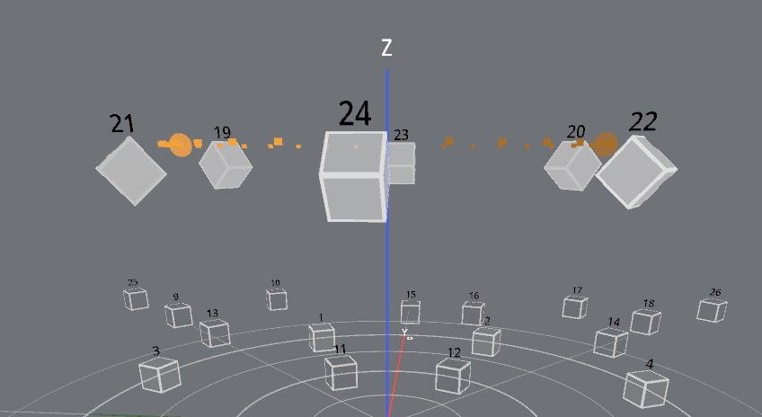

## 10.2. Using the PLAYER without you being present

The PLAYER (see chapter 6. PLAYER) is a very powerful tool in *SpatGRIS* which allows you to record a project in the original setup and then play it in another setup, in a concert hall for example. A typical situation is when one of your works is played elsewhere in your absence. You can then record your project using the Record function (see section 5.11. Recording) by checking the Export Speaker Setup box:



The audio files and the original loudspeaker setup will be saved in the same folder. You can send this one to your destination, who could play your piece on their own setup. This function is very useful for helping to spread multichannel music.

## 10.3. HYBRYD mode to vary the trajectories

HYBRID mode (see section 5.7. The HYBRID mode) is actually a DOME in which sources can be moved in CUBE mode. In exclusive DOME mode, the sources must be placed on the surface of the dome. This is imposed by the VBAP algorithm. It is therefore not possible to place a sound inside or outside the dome. By adopting HYBRID mode, the sources can either behave in DOME mode or in CUBE mode:

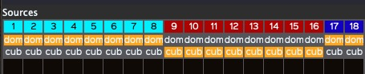

As can be seen here, some sources (in burgundy) are located outside the dome, while others (in light blue) are inside it:

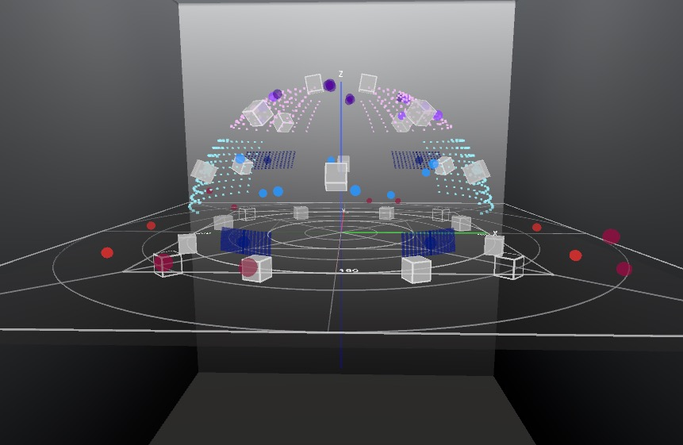

HYBRID mode allows you to vary the trajectories in DOME mode.

# Index

2

256 inputs and outputs · 8

3

3D and 2D views · 52

A

access to the microphone · 9

Activate · 26

AIFF is limited to 2 GB · 44

AIFF or WAV · 43

Alt for Windows · 50

Apple Silicon M1-M2 · 8, 10

automated presets · 26

automated trajectories · 26

Azimuth-Distance and Elevation · 19

Azimuth-Elevation · 18

B

Back & Forth · 24

BINAURAL · 43

*BlackHole* · 8

Buffer size · 11, 31

C

Cartesian (CUBE) · 18

Catalina · 8

CPU usage · 53

CUBE · 16

D

dampening · 24

Deviation · 24

Document format warnings · 52

DOME · 16

DP · 10

Drawing · 25

E

Extended Top · 20

Extended Top and Bottom · 21

F

Filtering (Hz) · 35

First Source ID · 17

G

Gaël Lane Lépine · 17

Global Sound Diffusion · 37

H

Head Related Transfer Function (HRTF) · 43

HYBRID mode · 32

I

Independent direct outputs · 39

Interpolation · 53

IP Address · 17

J

*Jack* · 8

L

Lemur · 8, 18, 59

Logic Pro · 10, 61

M

Matrix Base Amplitude Panning · 32

MBAP · 37

microphone · 9

MIDI tempo · 24

minimal requirements · 38

multiclient · 13

Mute and Solo · 42

O

*OctoGris* · 9

Olivier Bélanger · 17

Open Documentation · 53

Open Stage Control · 8, 18, 59

Option (Opt) for Mac · 50

OSC channels · 18

OSC Input Port · 31

OSC Input port number · 57

output level · 13

P

peak · 42

pendulum · 26

performance · 53

polar (DOME) · 18

R

*Reaper* · 61

*ReaRoute* · 8

Record button · 44

Reset Meter Clipping · 42, 51

Reset Sources Position · 51

S

Samuel Béland · 39

Save Project · 28

Save Settings · 28

Save Speaker Setup · 28

Security & Privacy · 9

server address · 57

Shift-Click in Drawing mode · 25

Show Speaker Numbers · 40

Show Speaker Triplets · 32

Sources Link descriptions · 54

Sources tab · 17

Spans · 20, 52, 53

*SpatGris1* · 10, 60

Spatialized direct outputs · 39

Speakers’ order · 37

*SpeakerView.* · 29

STEREO · 42

subwoofers · 39

T

The threshold is set at -70 dB · 50

Trajectories · 22

Trajectory descriptions · 56

U

uninstall *ControlGRIS* · 59

uninstall *SpatGRIS* · 59

V

VBAP · 17

Vector Base Amplitude Panning · 32

Ville Pulkki · 17

Volume (dB): · 35

W

WAV is limited to 4 GB · 44

X

xml format · 51

Z

*ZirkOSC* · 9

1. *BlackHole* is not mandatory. Any software that can send audio to *SpatGRIS* can be used. *BlackHole* is a HAL plugin.
2. See the format of the OSC messages in the Addendum.
3. JackRouter is a HAL plugin that was not compatible with MacOS 10.15 and up, and was not supported for a while.
4. Designed by Christophe Lengelé
5. See this link for more information: https://jackaudio.org/downloads/
6. Open Sound Control
7. The AAX plugin for Windows is signed using a self-issued certificate. It is unclear for now whether this is sufficient for ProTools and/or Windows Defender.
8. Since version 3.2.0, the LBAP, Layer Base Amplitude Panning, designed by Olivier Bélanger, is not in use anymore.
9. <http://opensoundcontrol.org>
10. See the Addendum manual for more information.
11. See the Open Stage Control manual for that: https://openstagecontrol.ammd.net/
12. On the Mac, most keyboards use Option (Opt), while others use Alt. Opt will be used in this manual.
13. It seems that on some Azerty keyboard, this key combination is not working. The function is still available though.
14. CAF (Core Audio Format) and WAV RF64 will eventually be implemented enabling size to exceed 4 GB.